EXCEED Content Management Guide

Abt Associates Inc.

What is a Content Management System?
A content management system (CMS) is a software tool that gives users the ability to add, publish, edit, or remove content from a website. The CMS software is written in a scripting language, and its scripts run on a computer where a database and a web server are installed.
Drupal is a flexible CMS based on the LAMP stack, with a modular design allowing features to be added and removed by installing and uninstalling modules, and allowing the entire look and feel of the website to be changed by installing and uninstalling themes.
For this project, we chose to use Drupal as a CMS because its easy on-line editing for less experienced content maintainers, uniformity and the possibility of adding more complex features requiring a database.
Actions commonly performed to manage content on the Exceed Website includes:
- Logging in
- Identifying and adding custom blocks
- Editing a custom block
- Adding a sub-section
- Editing a sub-section
- Re-arranging blocks

Logging in

To edit the contents of the exceed website, first a user must login to the Drupal instance of the website. The URL that will be used to login to the site is https://exceed.ri.gov/user/login once deployed to production but for our test environment we will use https://exceedtest.abtassociates.com/user/login.
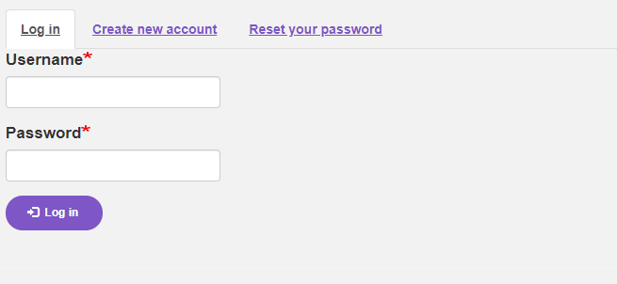
Once the user logs in with their credential, the user should be able to view the page below.
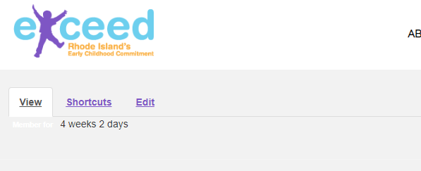
Before we proceed to show how we can add/edit/delete contents, this is a good point to explain what these tabs mean.

- Manage - This functionality allows the user display/hide the menu bar.
- Shortcuts - Users can create shortcuts of the most visited pages in the Drupal site. It provides a toolbar on the top of the page to which a user can add links to. Please Note - This toolbar and its application is site-wide, any links added will be visible to all users who have the permission to see the Shortcut toolbar.
- Flex Slider Examples – Users can use the Flex Slider library to build out slide shows on the website.
- User Profile – A user is able to view their profile, edit profile and log out of the CMS. The CMS Admin has the ability to add a user through the People functionality shown below.

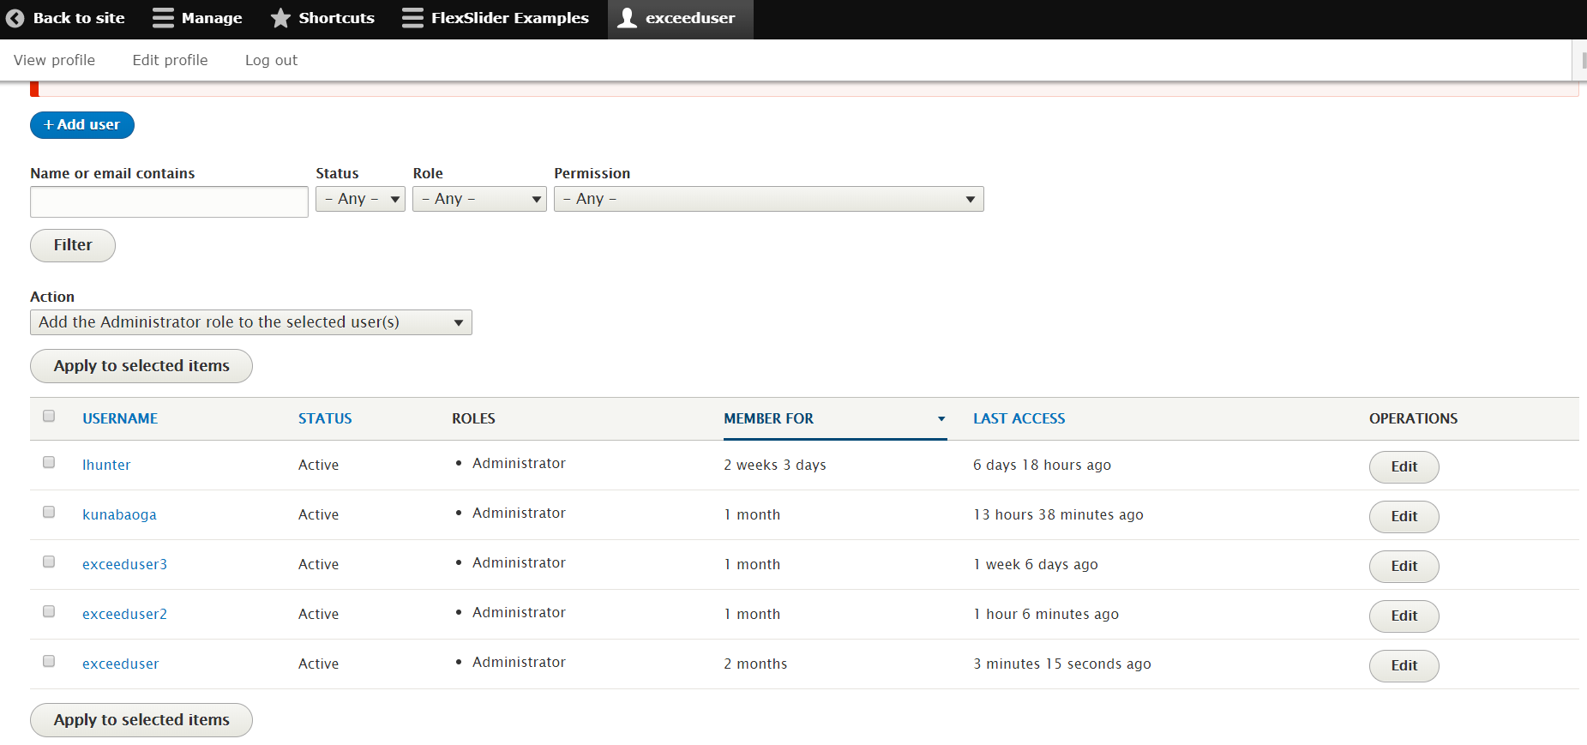

- Content
This page contains the list of all the contents added to the site. Contents are also called as ‘Entities’. The Content type is also called an ‘Entity type’.
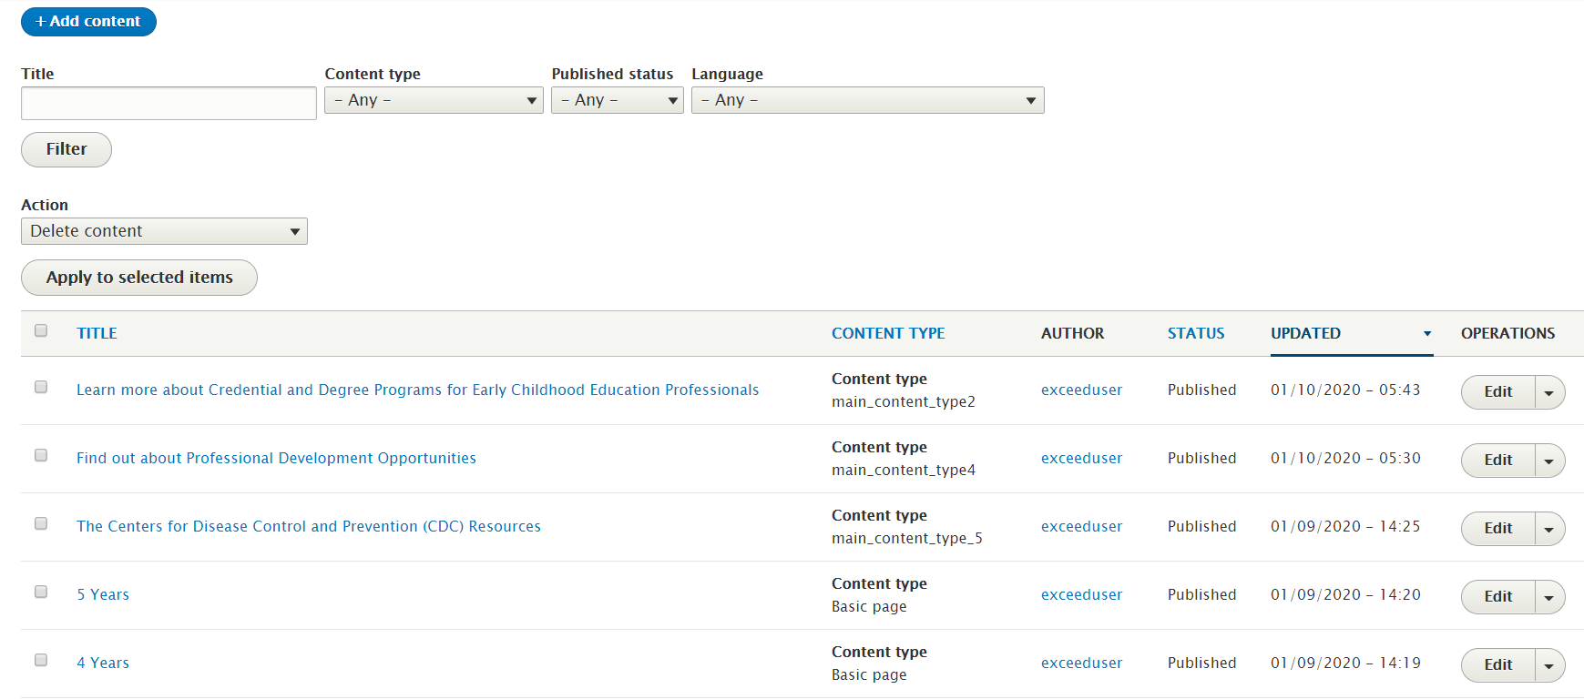

- Structure
Structure menu mainly contains sub-topics like Block layout, comment types, Menus, Pages, and Taxonomy etc.
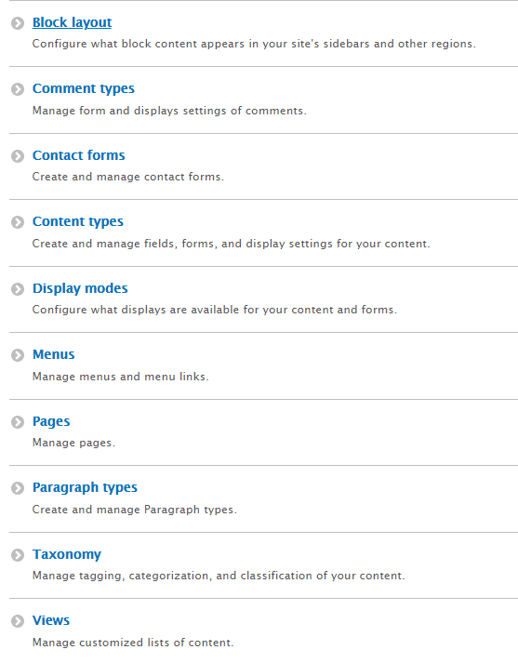
Block Layout: This page contains two tabs.
- Block structure/layout – Blocks here are arranged according to the theme on the site.
- Custom Block library - This is a HTML custom block which helps to display contents as desired with all HTML CSS decorations. This tab contains the list of all the custom blocks.
Content Types: Any content added to the site will belong to a specific content type. The content type are displayed below:

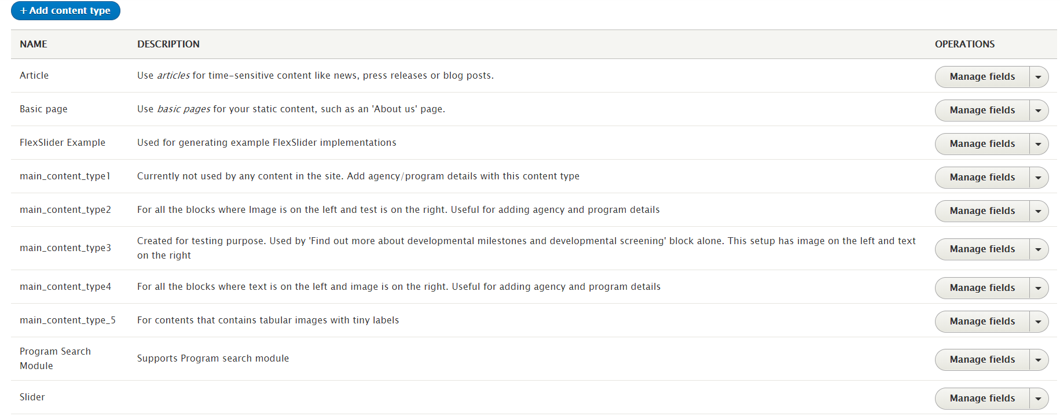

Display modes
Display modes provide different presentations of Content Entities for either viewing or editing. The two types of display modes are "view modes" and "form modes." Both of are examples of "configuration entities."
Menus
This functionality helps to manage the menu structure. Most of the Menu are built using Drupal core. For the Exceed site, we created ‘Main Navigation’ functionality for maintaining the menu structure.
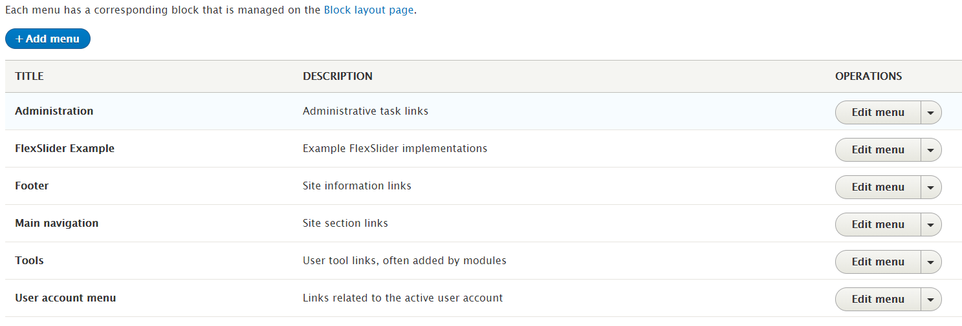

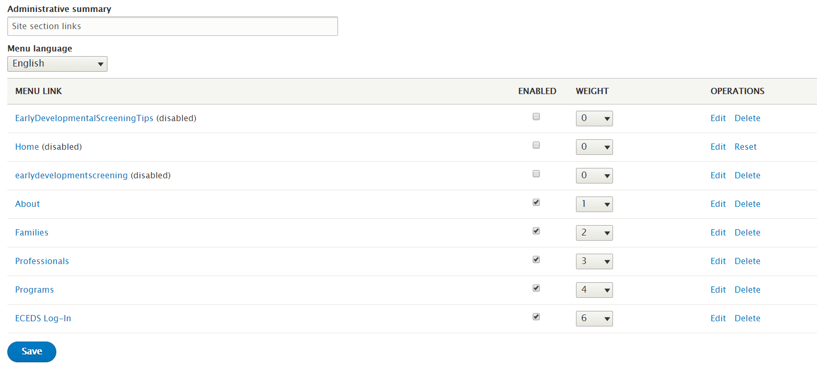

Paragraph types
This function allows the developers to make editing easier for the end-users. Rather than put all of their content in one WYSIWYG body field including images and videos, end-users can now choose on-the-fly between pre-defined Paragraph Types independent from one another. Paragraph Types can be anything the user wants from a simple text block/image to a complex and configurable slideshow.
The paragraph types are created mainly for 3 types of contents:
- Content having image on the left, text on the right
- Content having text on the left, image on the right
- Content having images with labels on both columns
Views
A view displays all the listing of content on a website. The core Views module handles the display of views, and the core Views UI module allows the user to create and edit them in the administrative interface.
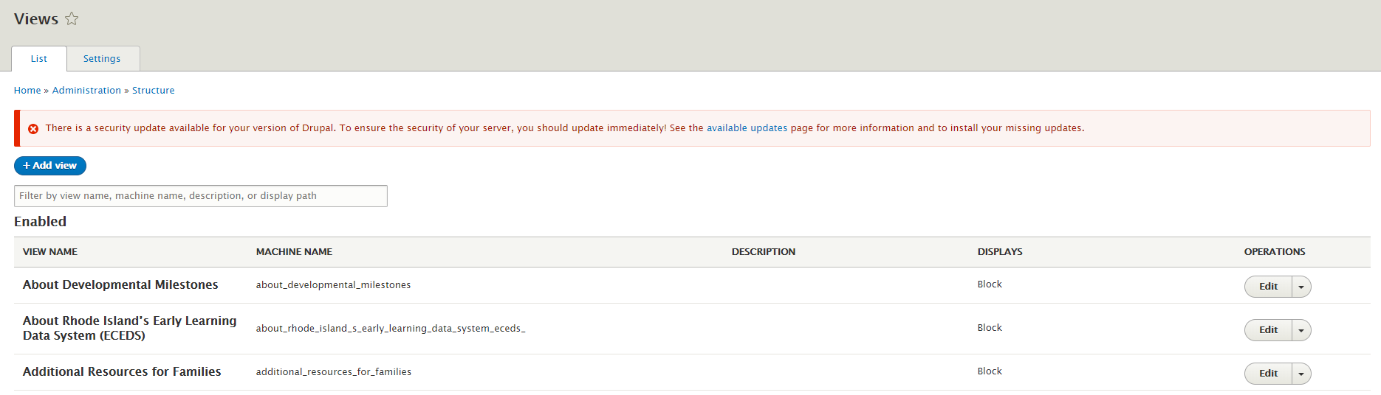
- Appearance
This functionality deals with the design/theme/appearance of the site. The Exceed site uses the ‘RI Theme’ created out of Bootstrap core. Drupal has 3 default themes – Bartik, Seven and Stark. On the settings tab, theme settings can be changed but we strongly recommend that only Admins should make these changes.

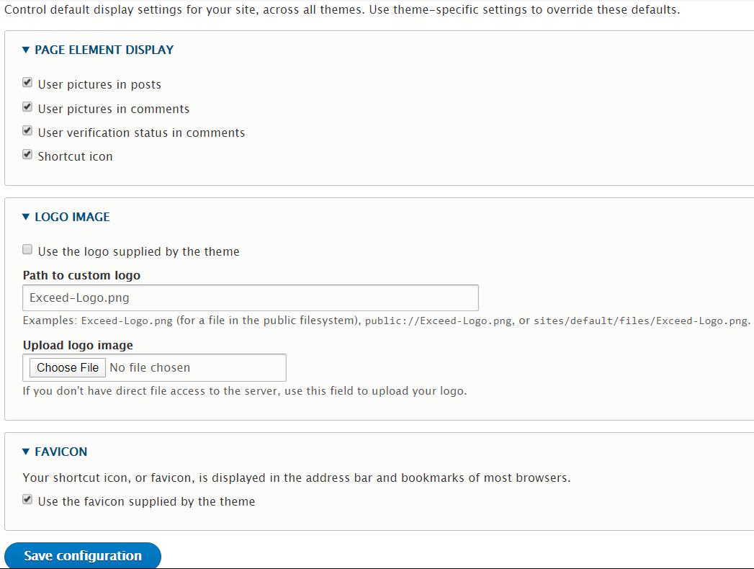

Extend
Drupal has a wide range of custom modules available to use and configure as we need to. The Extend module allows the user to extend and configure their site. To include a custom module in the site, for example, flex slider, the module source file should be downloaded from the corresponding Module documentation in Drupal.org. Once this module has been downloaded, on the Extend page, there is an option to install a new module – ‘Install new module’.

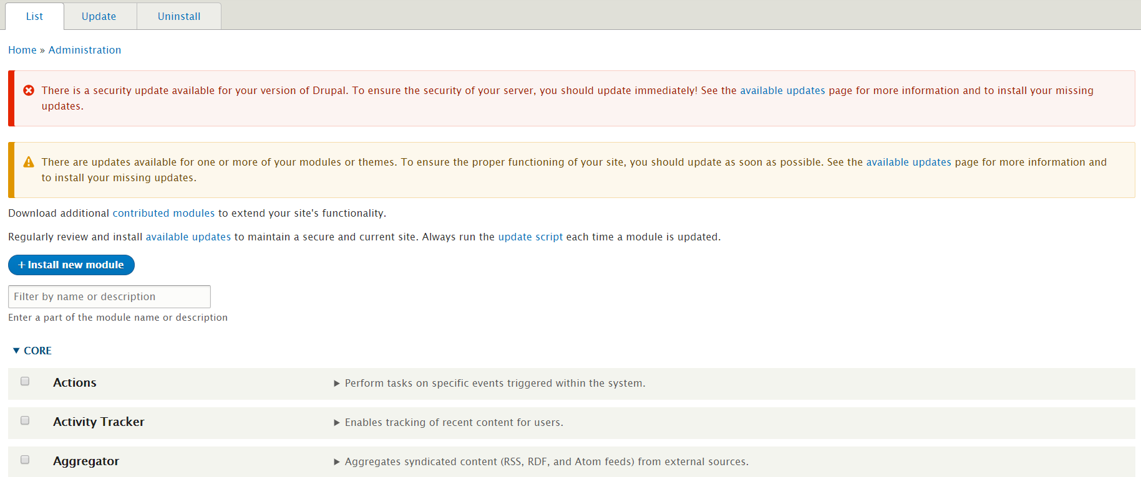
The List Tab will show the list of modules already installed and enabled/not enabled. The Update tab has the list of modules that need to be updated. The Uninstall tab will show all the modules already installed. The user can check the un-wanted module and uninstall here.
Please Note - DO NOT Uninstall any module since any portion of the site may be using any of these modules. Uninstalling the module will delete all its related configuration including the portion where the module is used already.
- Configuration
In Drupal, configuration is the collection of admin settings that determine how the site functions.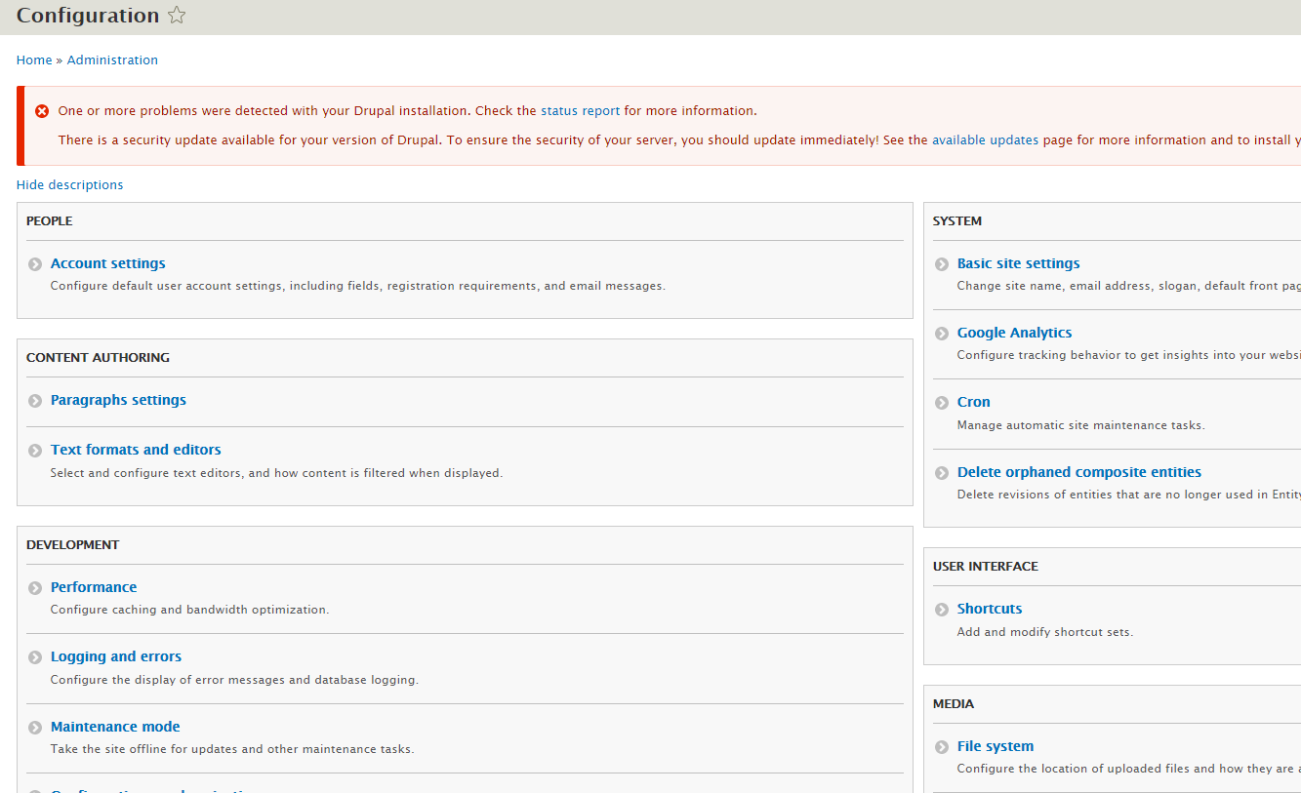

- People: In this section a new user role can be created and permissions can be set.
- Content Authoring: We have not used this module in our project. Paragraph settings is handled in Paragraph module and Text formats are not modified in this place. In the Text formats, Basic HTML, Full HTML, Restricted HTML and Plain text options are present. We are using Full HTML to get maximum functionality in HTML.
- Development: this section includes performance configuration (configure caching and bandwidth optimization. Cache clearing is done automatically when any core files are edited), logging and errors configuration, maintenance mode configuration and PHPExcel cache settings.
- Search and metadata: Every page in Exceed is saved as node/nodenumber on the system and displayed by an alias. These aliases can be changed here or in the Menu setting or in the Content page. The changes will still be reflected here. The Search API module is used for site wide searching.
- System: Site settings, Google Analytics, Cron (time-based task scheduler that can be configured to automatically execute tasks without any manual involvement beyond the initial configuration) and Delete Orphan Composite entities functionalities are configured here.

People
This tab displays the list of all authorized users with various access levels to the site.

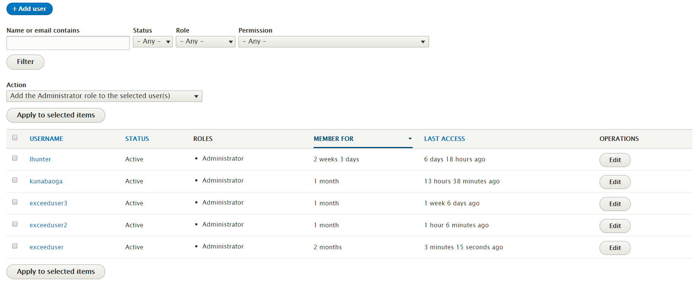
A new user can be added by clicking ‘Add User’ button and following the prompts. The user can search for other users by entering their name or emails in the search field and apply the filter criteria. Other administrative actions can be applied here.
- Reports
Reports here does not refer to any type of custom reports. Rather, they function like a ’Log’ or ‘Status reporting’ feature. Every functionality under Report provides a status about the Drupal site.
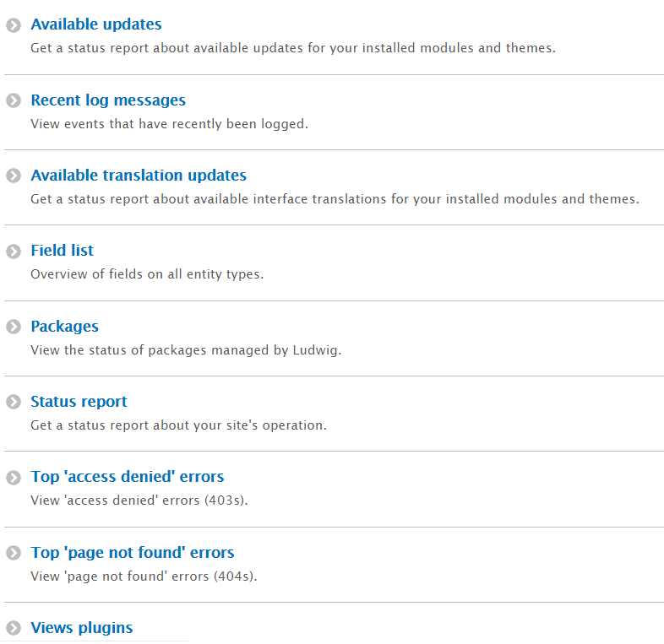

- Help
This page contains all the resources that a user/admin will need to work with this site. This resource is equally helpful for all Drupal users.
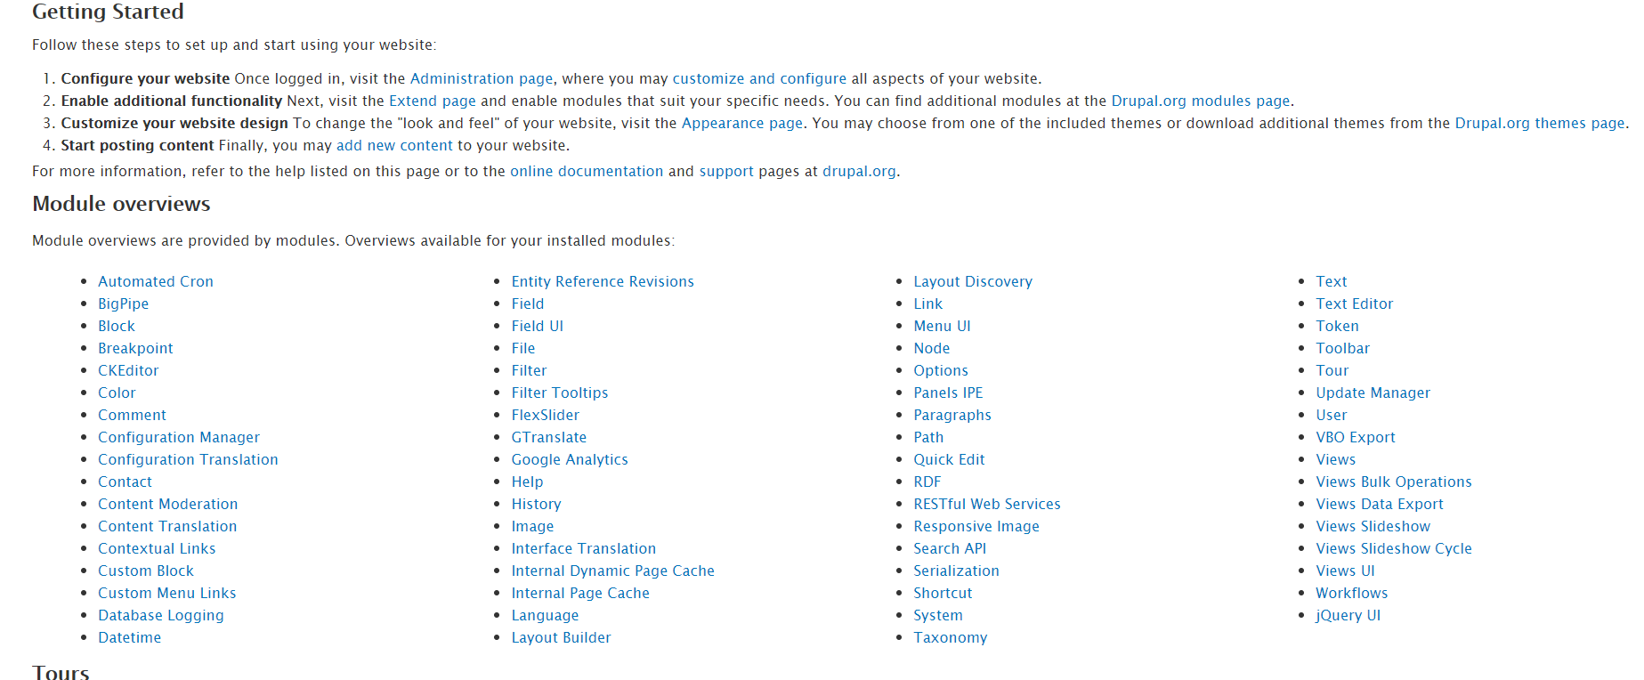
Now that we understand what these menu items do, we will proceed to learn the basic actions that we can perform. These are simple actions that anyone can perform, advanced Drupal functions will be covered in a different training.
Most of the custom-blocks used on this site were created with the intent to re-use. Deleting any block will remove the content from all the places in which it is used in the site and its related configuration. Please contact the administrator before you make any changes.

- Adding Custom Blocks
Blocks in Drupal are pieces of content that can be placed anywhere in the site. They are an integral part of Drupal and the way it displays information. They can contain simple text, forms or something with complex logic.
How to identify a custom block: There are a couple of ways that a user can identify a custom block -
- The user navigates to the page to edit the contents in a block, when user the user hovers near a block and clicks the edit pencil, the options below are displayed. This confirms that this is a custom block.

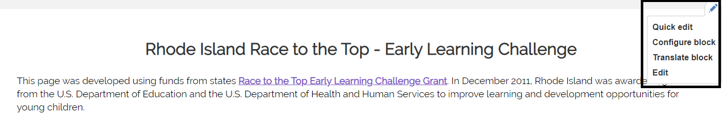

- Another way to identify a custom block is to select Structure >> Block layout >> Custom block library. This section will show the list of all the available custom blocks in the site.
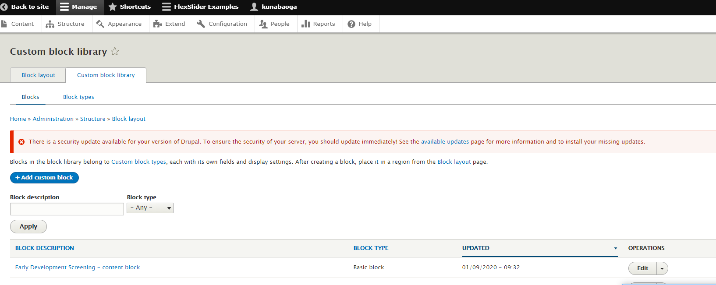
Steps to add a new custom block:
Custom blocks are custom HTML contents that can be added and placed anywhere in the site. Minimum level of HTML knowledge is required to handle custom blocks. The pre-existing custom blocks can also be re-used.
- Navigate to Structure >> Block layout >> Custom block library tab. Select ‘Add custom block’ button to add a new custom block.

- The Block description field describes the title, Body description field should contain the content to be displayed. Select ‘Full HTML’ on the Text format dropdown and save the custom block.
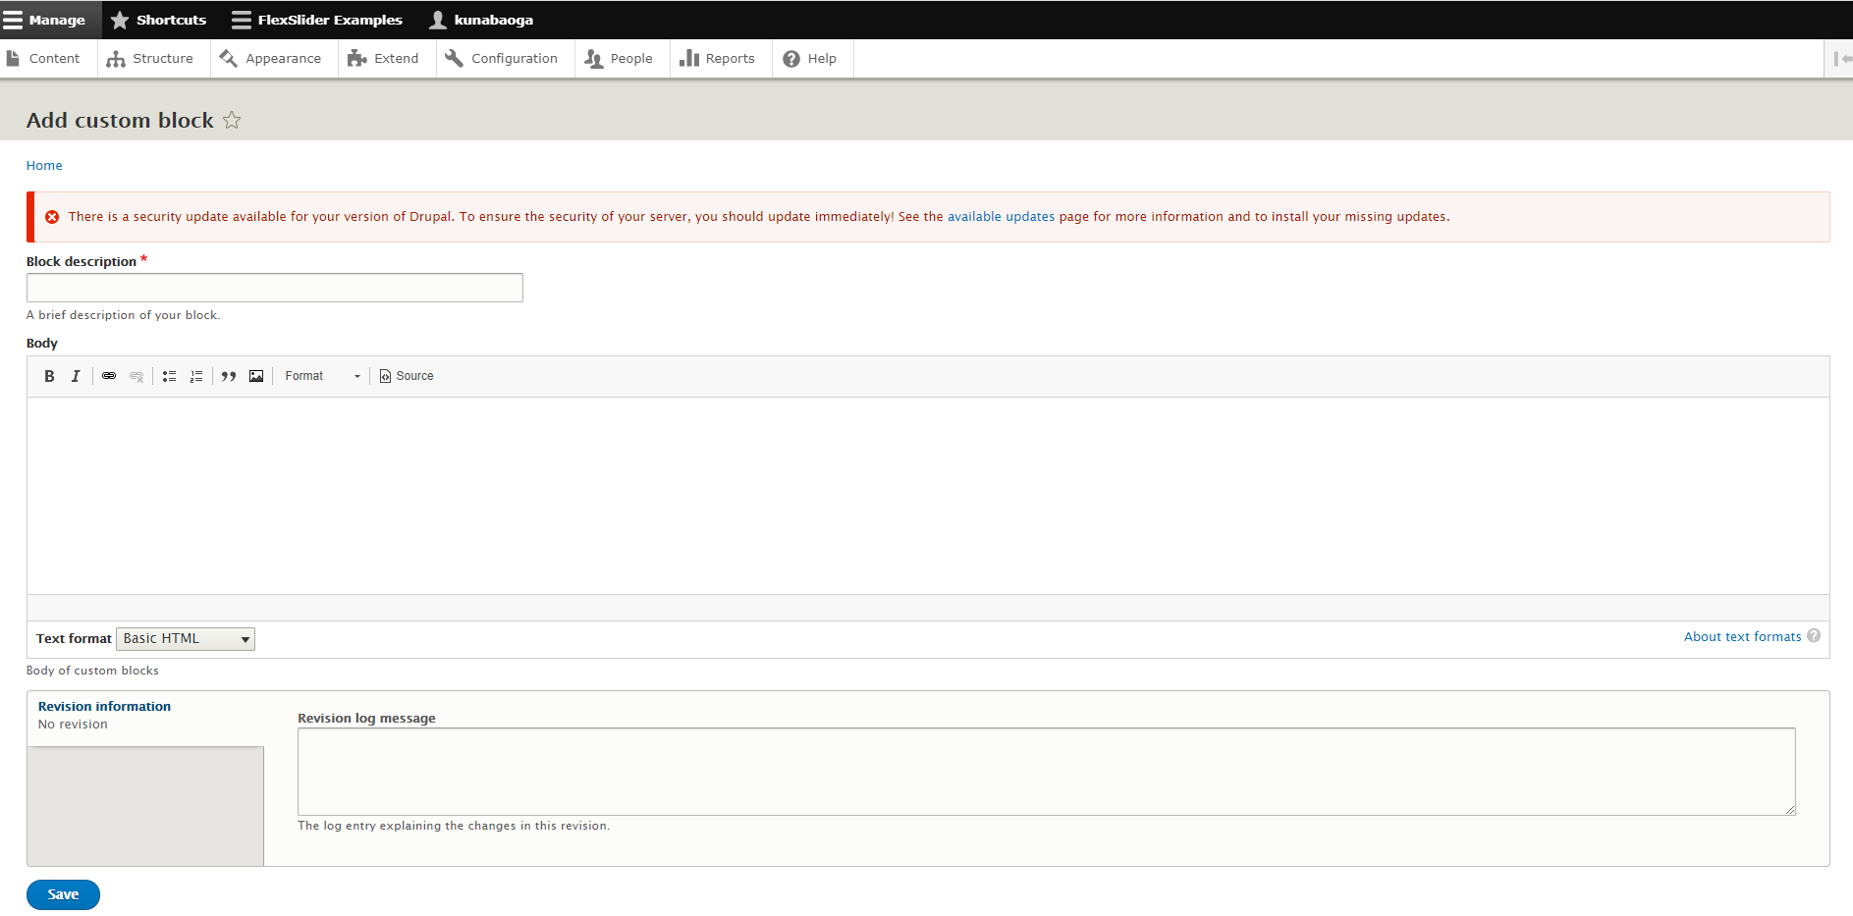
- Once the block is saved, the block needs to be placed in the right location on the site. Select ‘Block layout’ tab and find the location where the block needs to be placed. And then use the ‘Place block’ option to complete this action.
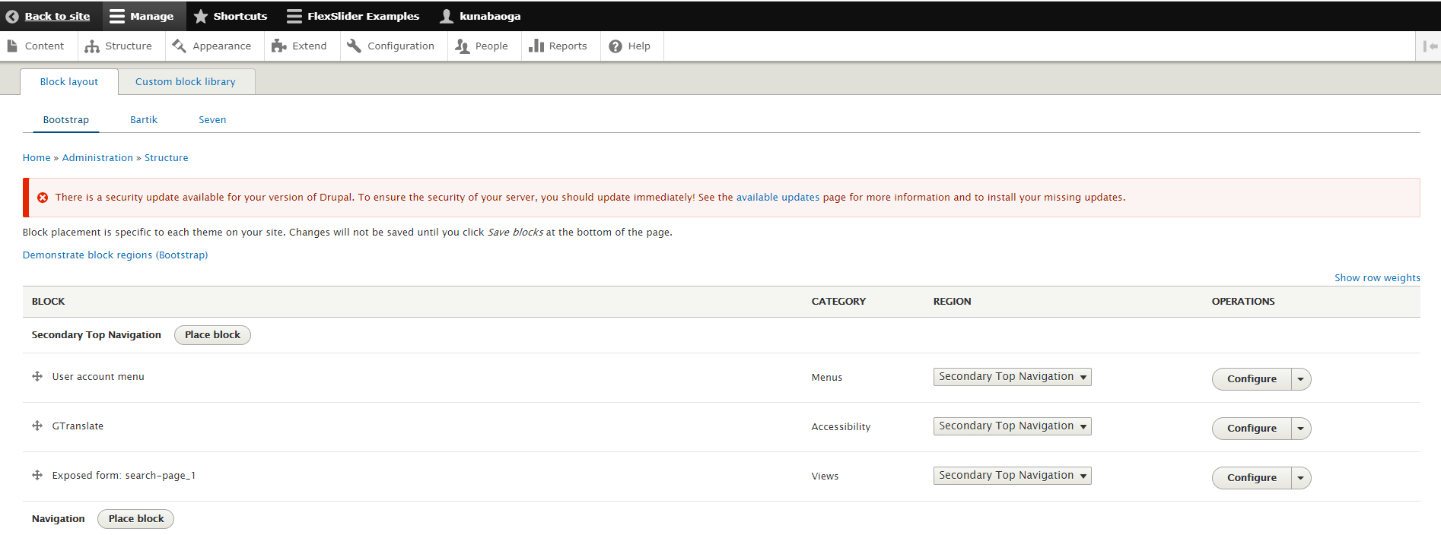

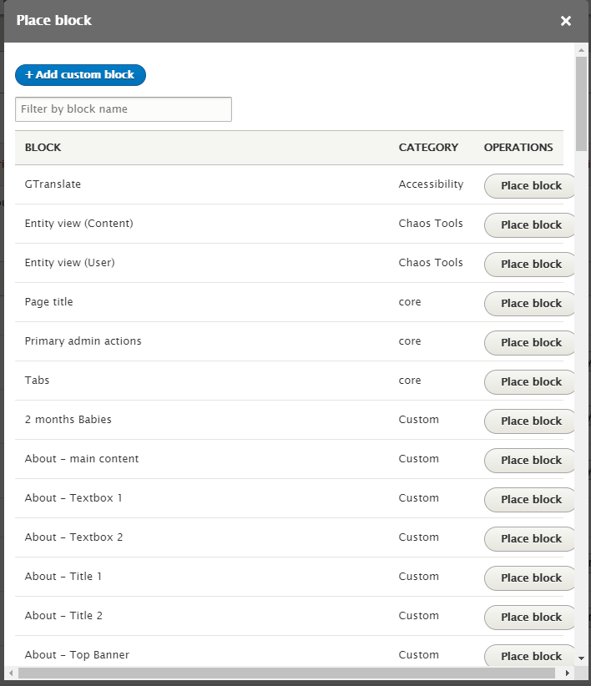

We can also create a new custom block with the same layout as the content in another block by copying and pasting the source in the new custom block body.
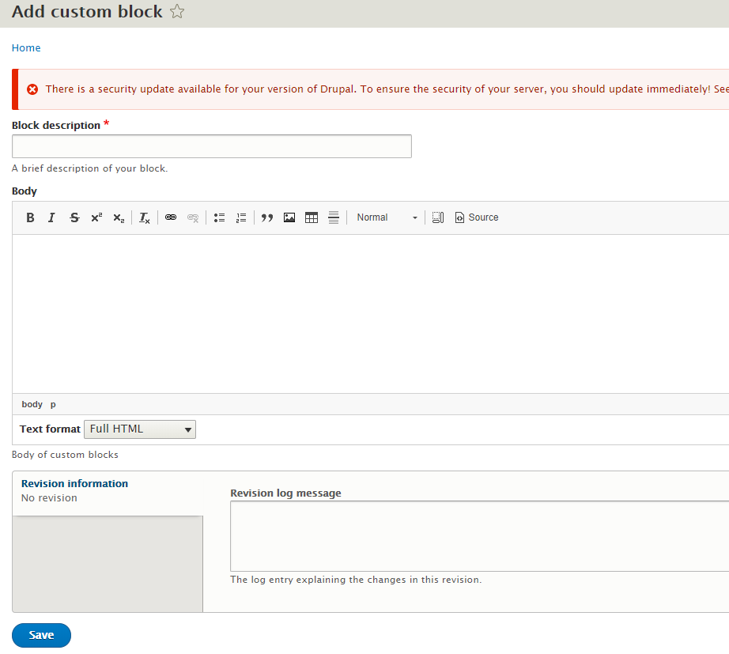

Configuring a custom block
This is a crucial step. Navigate to Structure >> Block layout >> on the operations column, select the ‘Configure’ option. This Configuration process is the same for a new custom block as well as an existing custom block.
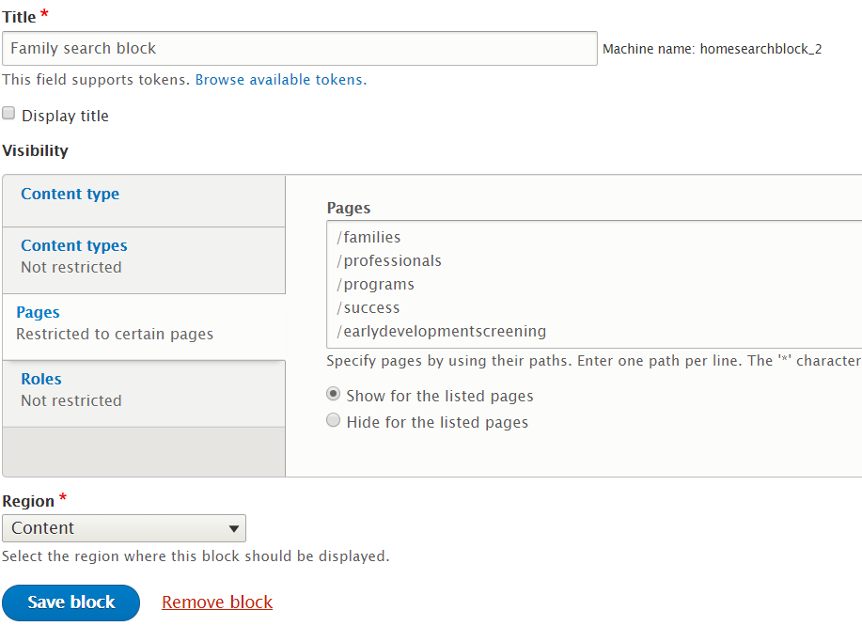

- Edit a Custom Block
Steps for editing a custom block is pretty much the same. A block can be edited directly by clicking on the ‘Edit’ button on the specific block.
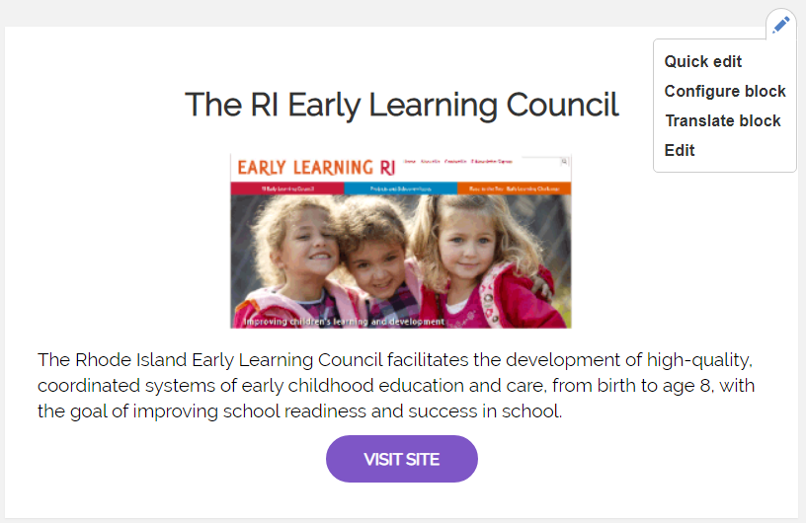

Alternatively, the user can also navigate to Structure >> Block layout >> Custom block library tab. Find the block they would like to edit and can edit the content and save.

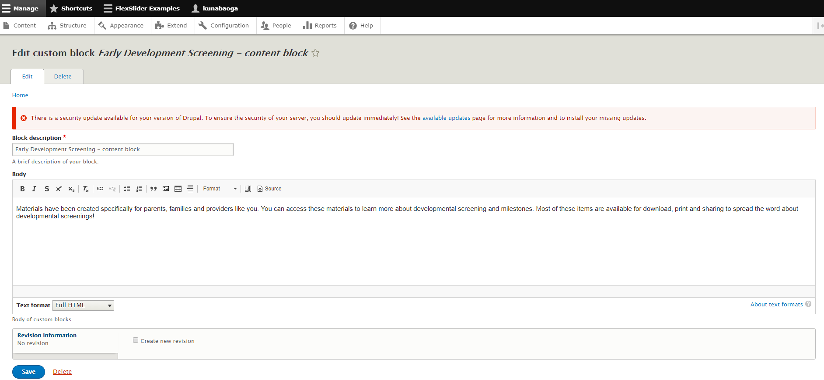

- Add a Sub-Section
For the purpose of our training, we will define a Sub-section as content blocks with text on one side and an image on the other. We can find these sub-sections on the Families, Professionals and Programs pages.
To add a new sub section, Navigate to ‘Content’ and select ‘Add content’ option. Select the content type as ‘Main_content_type2’ or any content type that you would prefer.

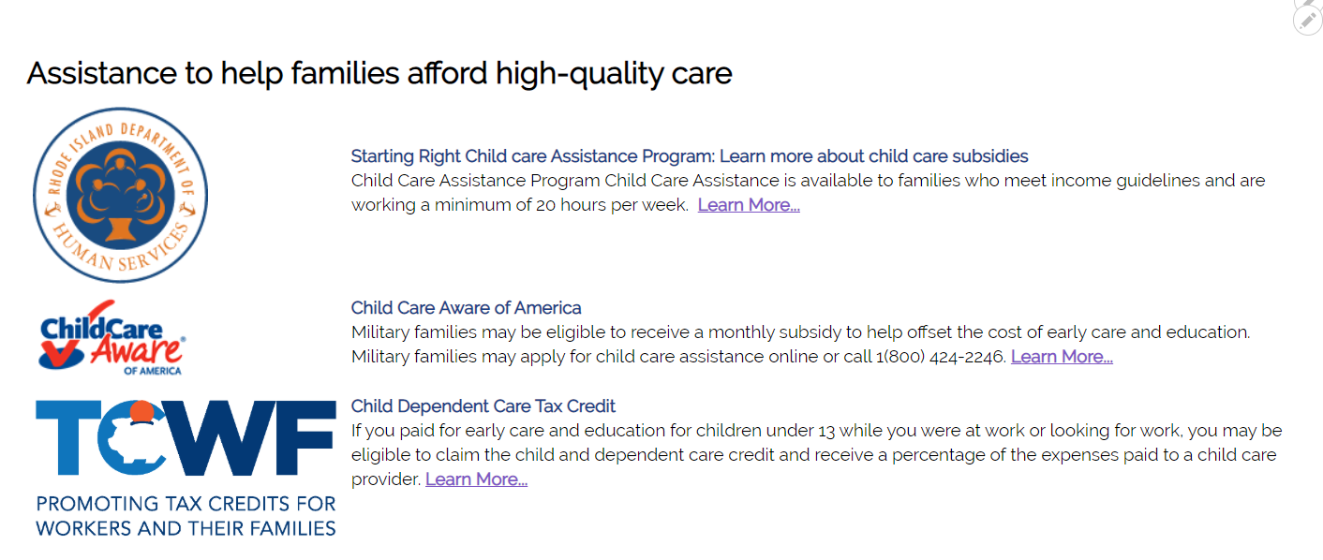

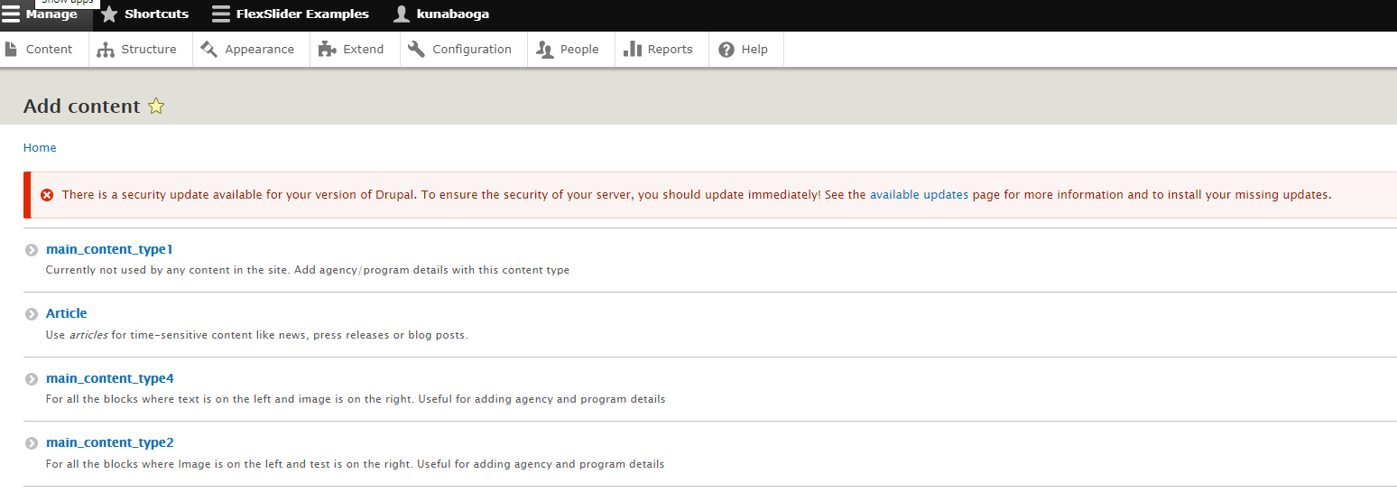
The page launched will display the ‘Title’, ‘Image’ and ‘Body’ fields. The user can add contents in the ‘Body’ section and change the text format to ‘Full HTML’ and upload an image according to the specifications allowed. Once the first set of content is added, if you have more contents that you would want to add, select the ‘Add Paragraph2’ option to add the next set of content and the corresponding image.

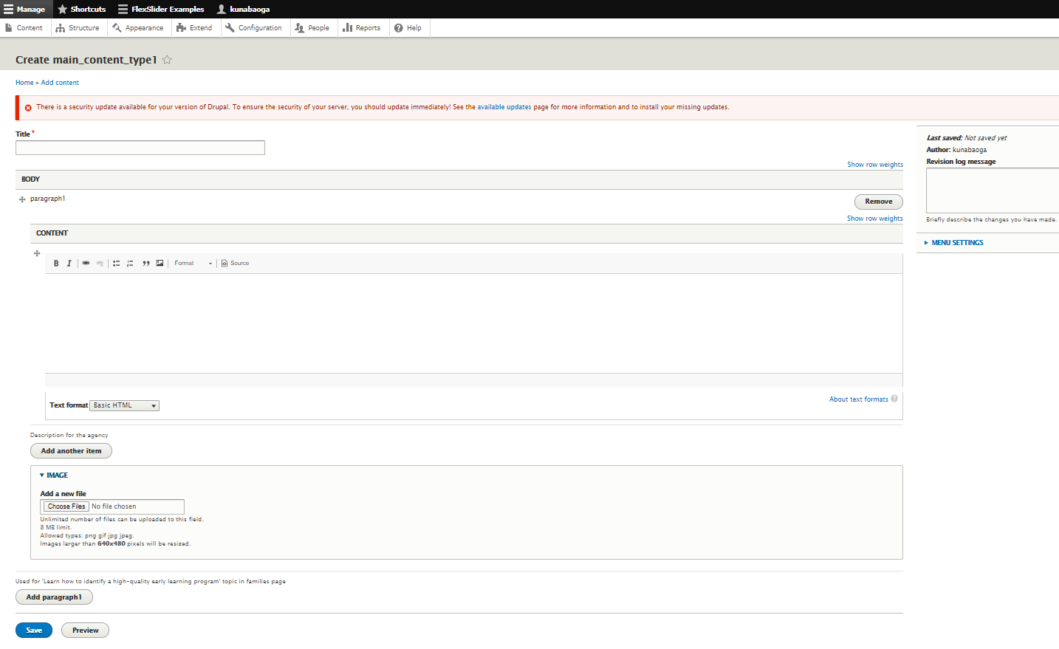

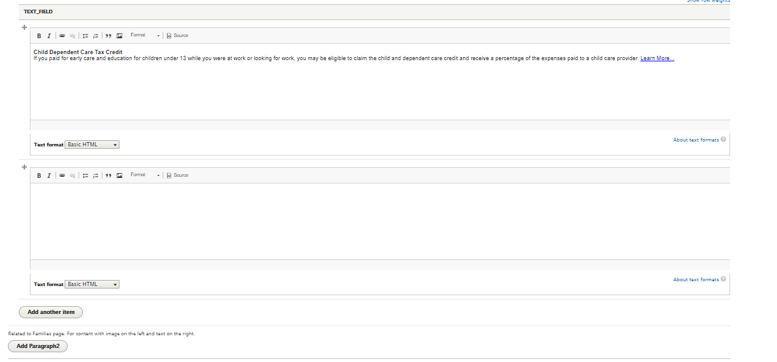

DO NOT select the ‘Add another item’ option. This will distort the current configuration setup. The next steps outlined below should be done by an admin ONLY.
Once the content is added, a view has to be created to display the content block. A user can create a view by selecting Structure >> Views >> Add view. The view name entered has to be the same as the content title and then select the ‘Create block’ checkbox to create the content as a block.
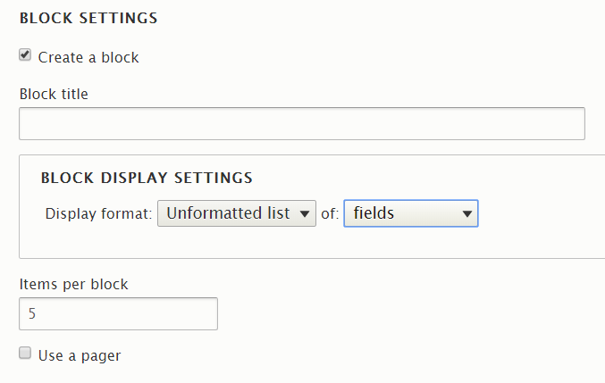
These settings will create a fresh view for the user. In the view settings page the below configurations should be made:
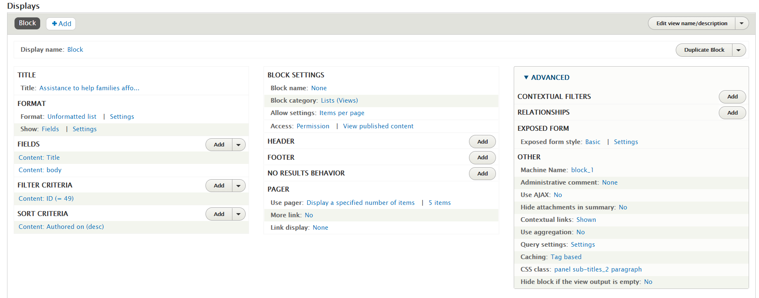

Once a view has been created, we have to place the content block in a specific location on the site. To do this, navigate to Structure >> Block layout. Select the ‘Place block’ button on the specific location to place the view block and configure it like a regular custom block.

- Edit a Sub-Section
To edit a sub-section on a page, copy the title of the sub-section, navigate to “Content” page and then paste the copied title in the Title field and select ‘filter’.

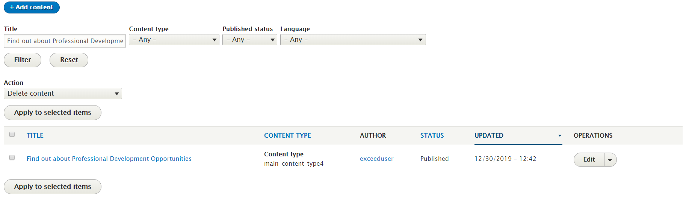

When the user selects the ‘Edit’ option, user gets redirected to a page where the content can be edited.
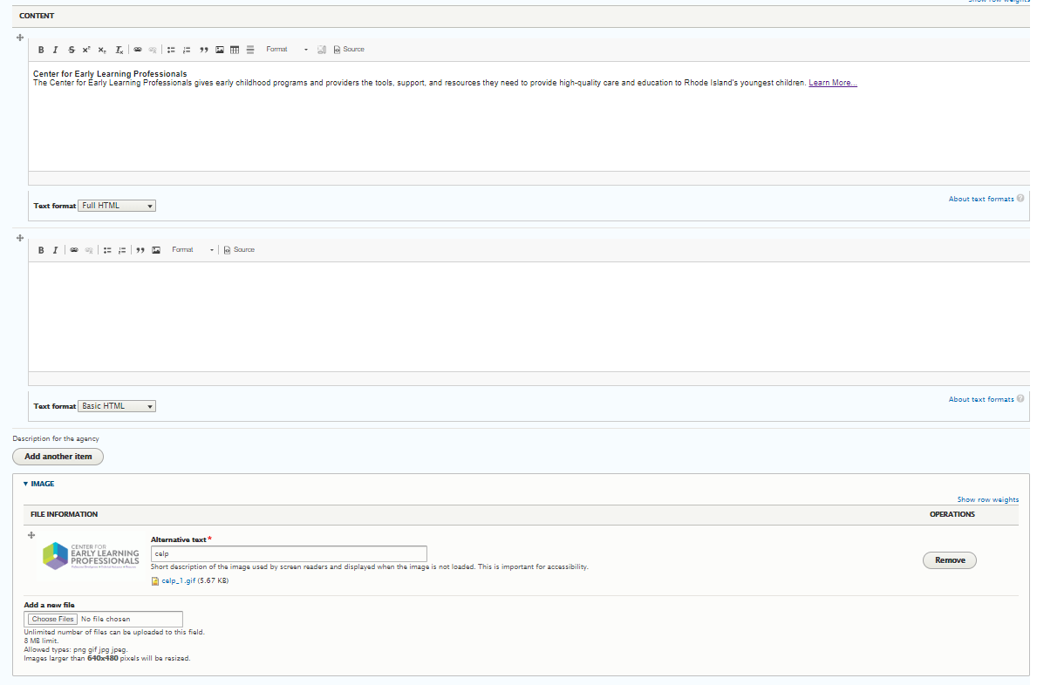

To change an image on any of the subsections, the user has to first remove the existing image and upload a new image with an ‘Alt’ text. Additional contents can also be added to the same sub-section in the same place. Please Note – remember to save all changes or you will lose your content.

- Re-arrange blocks
All of the contents in every page is arranged in the ‘Block layout’ section. If a user would like to re-arrange the order, the user could navigate to Structure >> Block layout tab. On this page, the user can simply ‘drag-and-drop’ the blocks in the preferred order.
Please Note: Many blocks are created once and re-used in many pages. Hence moving the blocks to a different section may impact more than one page where it is used.

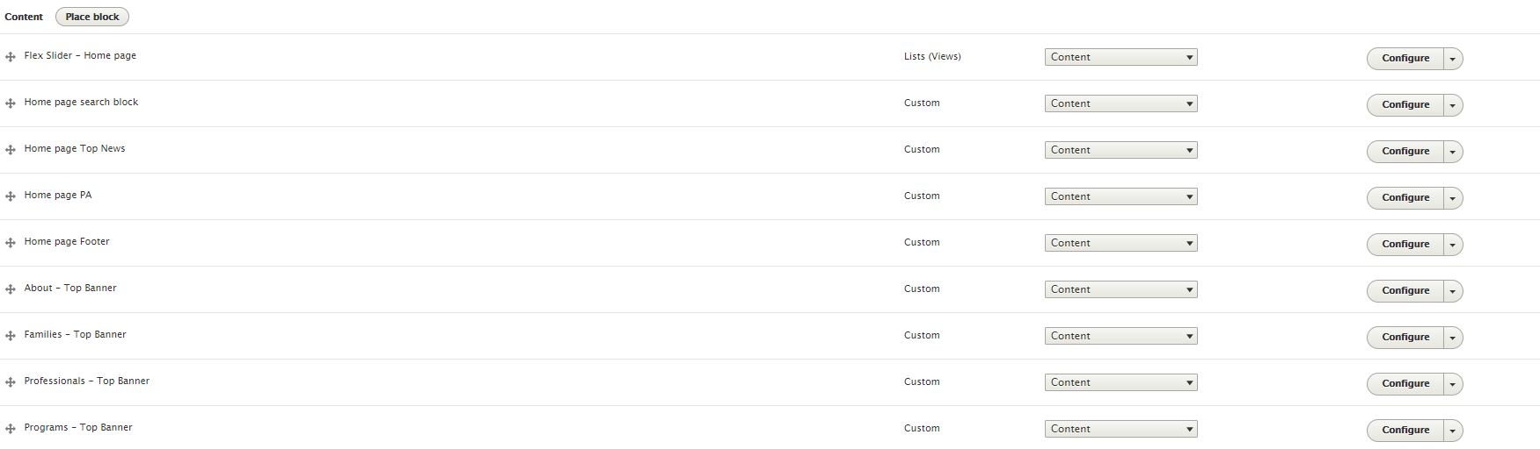

Drupal Content Management Best Practices
- Custom blocks: These are set of custom HTML blocks created for static content. Users of this block need some basic HTML knowledge. If it is just a content edit anyone can edit the data without changing any HTML tags. Our rule of thumb is to only enable the blocks you really need.

  - DO NOT edit any pre-existing block
  - DO NOT delete any pre-existing block
  - DO NOT rearrange blocks – particularly the re-used blocks
  - DO NOT edit any HTML tags but you can edit the content/data
  - You can create a new block which has the same features as an existing block by replicating the code of existing block to the new block and edit the contents. That way the structure will be inherited and data will be populated correctly.
  - Steps to build a custom block – please refer to the steps above.
- Themes/Appearance

The site uses Bootstrap as the base theme and exe as the sub theme. The sub theme is created with a specific intention. We recommend that this theme should not be changed or any of the style as this is custom tailored in the styles.css file. The main and only style sheet that we created is the style.css and we do not recommend any changes to this file.

- Content Template

Content templates are created for users to add or change existing content. There are mainly 2 content types – MainContentype2 and Maincontentype4. The content type will have description for why it is created. We strongly recommend that you use existing content type.

- Objects

Main objects that are used by an admin user would be DOCS or IMAGES. The docs and images are stored in the path below:
../../web/sites/default/files/docs/….
../../web/sites/default/files/images/….
If the user would like to upload a new document or image, the user should drop the objects in the corresponding location to access them.

- Users:
While delivering the product, Abt plans to create an admin user who is a super user and will share the credentials with the RIDE team. Please Note - We strongly recommend that only few admin users should be created.

