Licensing and Monitoring Module user GUIDE

Abt Associates Inc.



# Licensing and Monitoring Module

Abt built Rhode Island an electronic solution which involves an assessor gathering the monitoring visit data on a web form and a supervisor approving these applications to be published for public consumption in Exceed. We built this module in Drupal to allow the ability for Rhode Island to manage their content and possibly update/make changes to the forms themselves.

Below we define the users and their roles.

## Roles and Users

For simplicity, we created four roles and set appropriate permissions for these roles.

1. The Administrator – Creates users and sets permissions. We have an administrator (Nicole and Sarah) who will create other users and grant permissions.
2. The Supervisor – reviews submitted web forms and completes the necessary actions. Please note, a supervisor can have more than one role (Admin and Supervisory role).
3. The Assessor – visits programs/providers and gathers data on a web form.
4. The Public – we did not create a specific role for the public, but set permissions for what information the public can access.

## Licensing and Monitoring Process

Initially, the accessor gathers data on a paper based form, summarizes, converts and uploads this data in a PDF format, and this is made in DCYF.

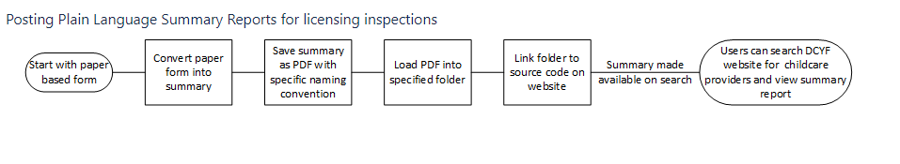

Licensing has since been moved to DHS and now this process is simplified in ECEDS and the reports are made readily available to consumers with a simple program search in Exceed. The current implemented process involves a simplified workflow of interactions between the assessor and the supervisor.

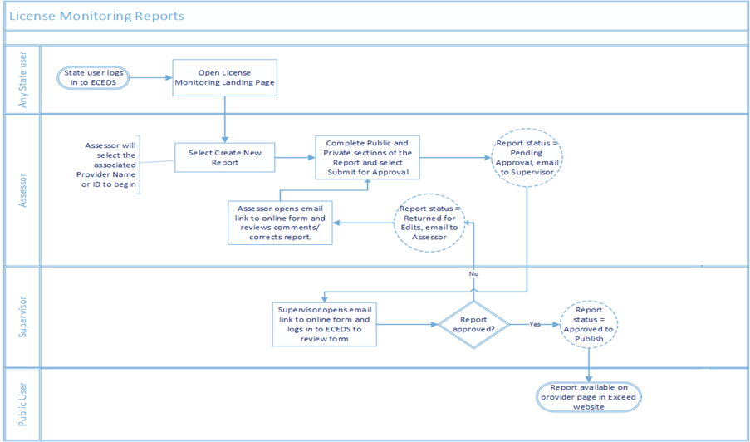

# Step by Step Guide on how users interact with the system

1. **The Administrator**

The Administrator creates all other users, assigns roles and sets permissions. Please note that the admin user name has to match the name in ECEDS. Users can be added by following these simple steps in the content management system (CMS).

* Log in

First, the admin must sign into the Drupal instance in Exceed to edit content or add users using the following link <https://exceed.ri.gov/user/login>.

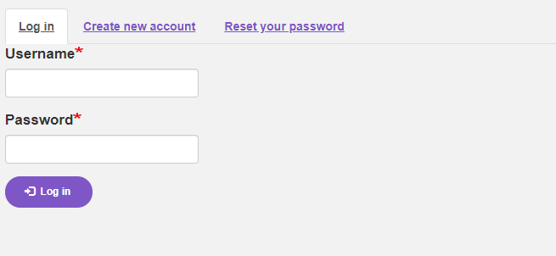

The user then sees the following landing page

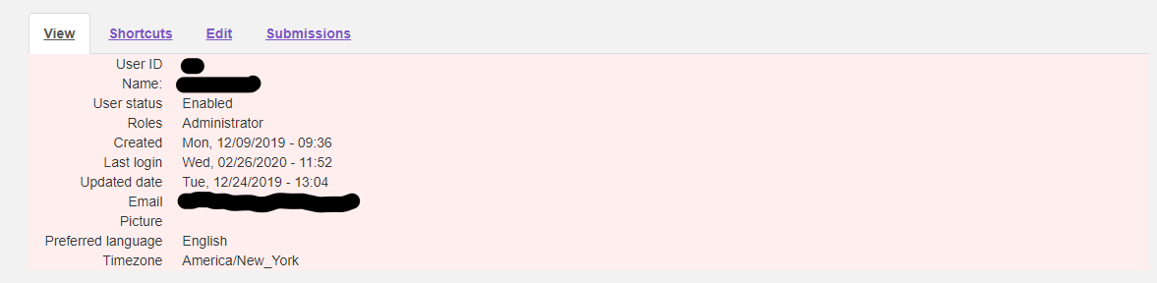

* Create Users

When the Administrator hovers over the People functionality in the menu tab, the admin user will be able to add users and set their permissions.



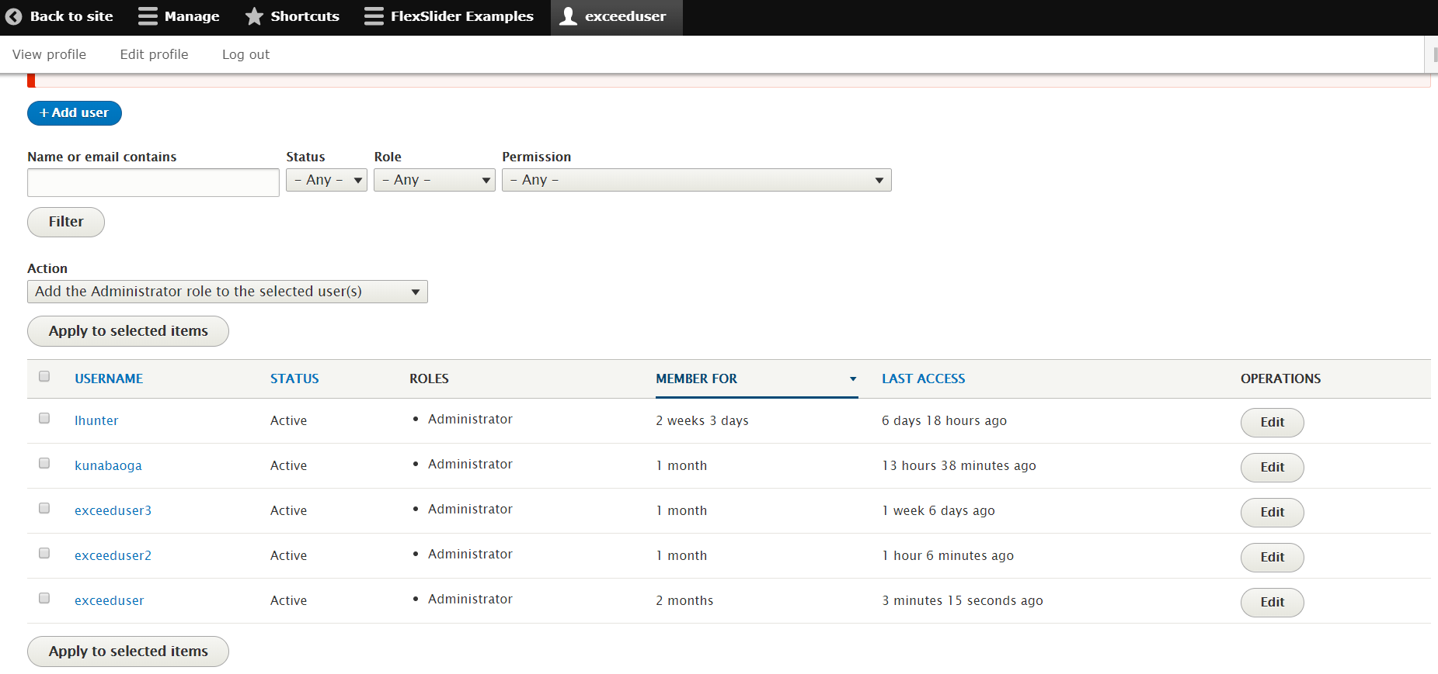

Now that our users have been created and their roles assigned, next we will walk through how this forms are documented and how it goes through the approval process. These forms were developed using the Web form module in Drupal and they are quite complex and large.

**Please Note** – when a report is mistakenly published, an admin can change the submission status or remove the report from Exceed.

1. **The Assessor**

The assessor visits a program/provider and gathers data on the web form. To begin the data gathering process, the assessor must first log into ECEDS from their tablet.

* Log in

The assessor logs in via ECEDS and navigates to the DHS agency and from the DHS agency landing page, selects the Licensing and Monitoring module.

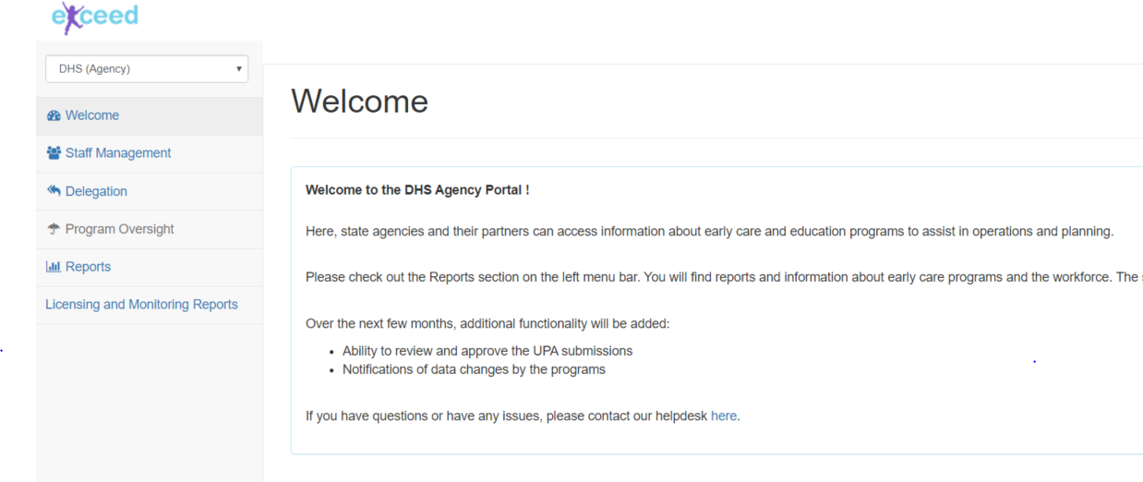

* Create a new application

The assessor landing page is displayed once the assessor selects the licensing module. We see the assessor landing page displayed has two sections. In the first section, the assessor searches for the provider/program by their ID or name (first few letters will return a couple of results) and then selects “create” to open the appropriate licensing form. In the second section, the assessor views submitted applications, status and supervisor feedback.

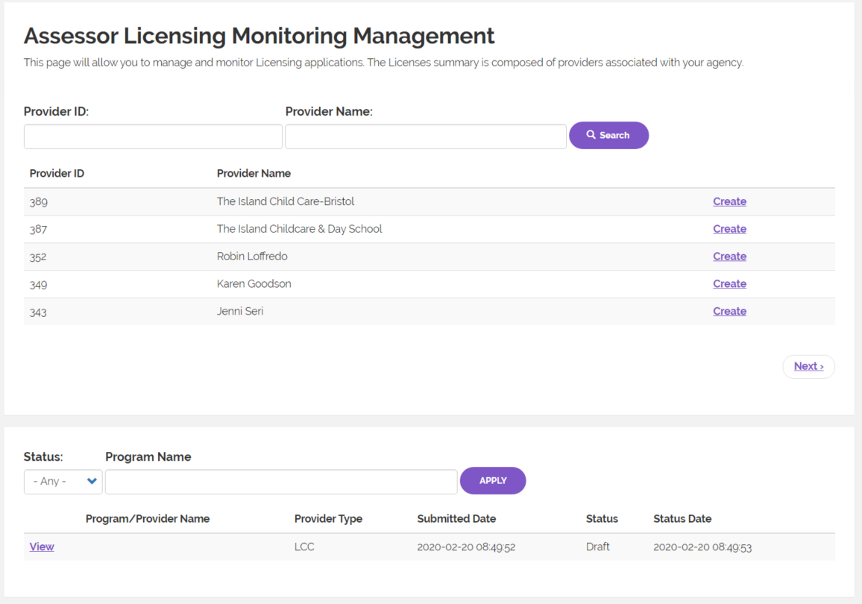

Once the assessor starts to create a new web form, the next step is automated to prepopulate basic information like assessor name, program information and the visit end time. These fields are editable so the assessor is able to override any prepopulated data.

There are two types of forms – the G/FCC and the LCC. The forms were implemented using the [Webform](https://www.drupal.org/project/webform) facility (module) in a Drupal web site. We also automated the right form to be pulled depending on provider setting type. For ease of navigation, we added bread crumbs which shows the assessor where they are in the application process – each of these pages are labelled.

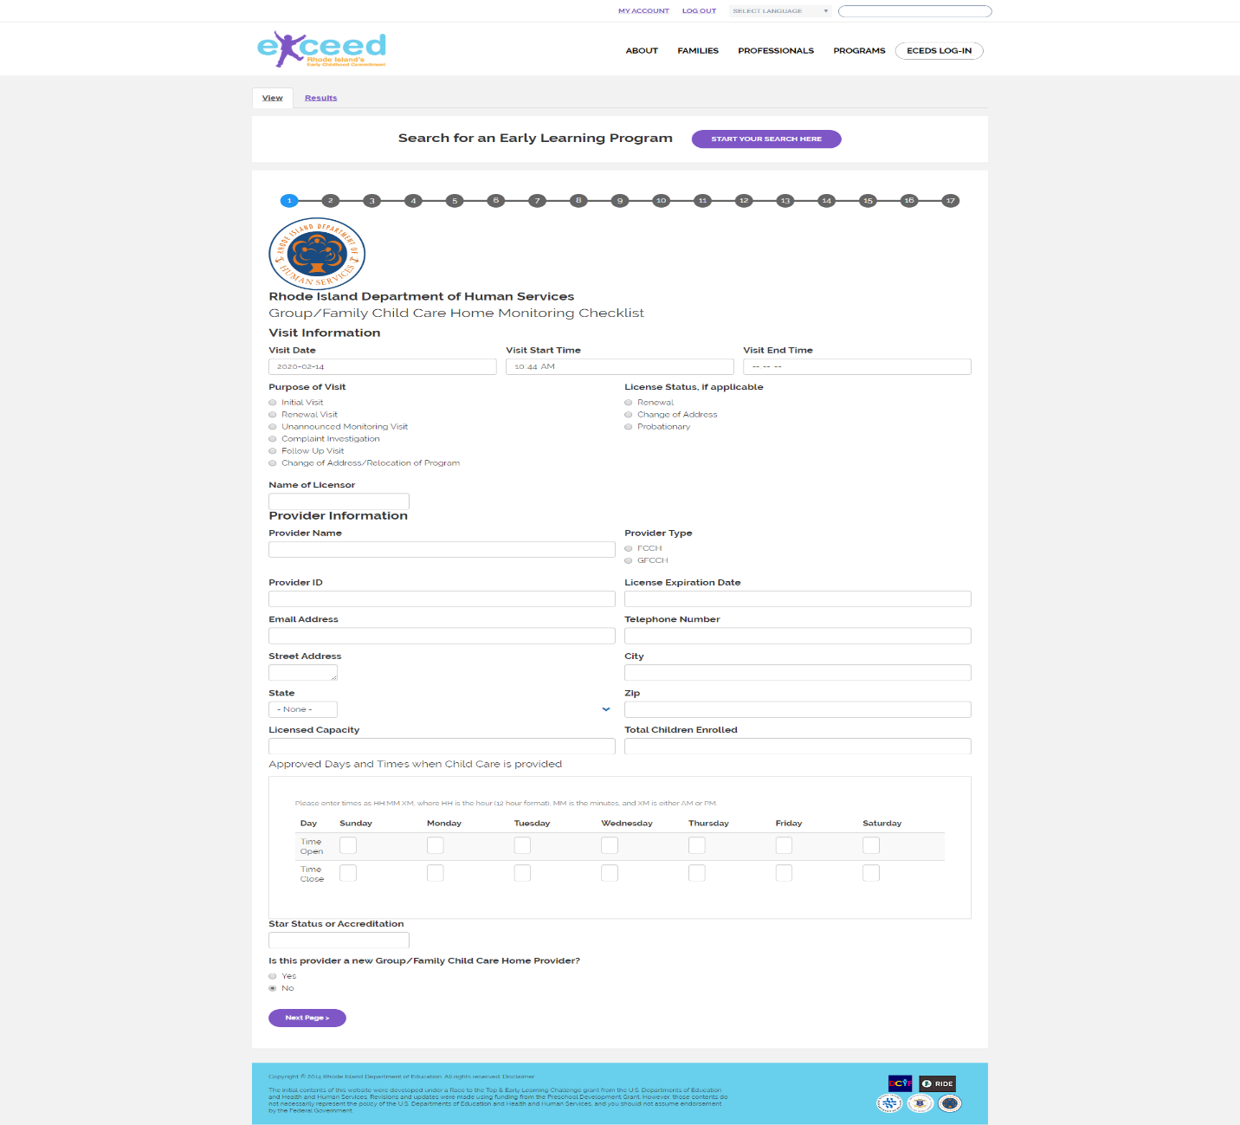

**Please Note –**

* The “Additional Reporting” section has a question about arrests. If you click on “Yes,” a box will open up where you can enter the details.
* The Corrective Action originally shows a box where you can enter the regulation ID of a non-compliance. Below that, there is a “Details” line; if you click on that, additional fields are shown to complete the Corrective Action Plan (CAP).
* The Visit End Time will be updated automatically but the fields are editable.
* For both forms, some existing data can be pre-populated in the form by adding a URL query parameter (?nid=*xxx*) that points to the program’s “Program Search Module” content.
* When an assessor/licensor is completing a form and comes across a field depicted below with dots in the lower right corner, the assessor may place a cursor on the dots and drag down to expand the field.



## **Child Care Center and School Age Program Web Form**

* For the Classroom/Activities Observed, one line is shown, but this is an expandable/collapsible section and can accommodate as much data as we want to add.
* The same applies to section 1.8, this section can be expanded or collapsed.
* For the Staff File Requirements section, there is a field for staff name and below that, a “Details” line which when selected displays additional fields to be completed. You can select “Add another,” to add more staff or select the “Remove” to delete any added data. The same applies to the Child File Requirements section.

## **Group/Family Child Care Home Web Form**

* At the bottom of the first section, the question, “Is this provider a new Group/Family Child Care Home Provider?” is displayed. If you select “No,” you can proceed to the next question. If you select “Yes,” this skips several sections automatically.
* For the “G/FCCH Assistant and Emergency Assistant” section, you can select “Add another,” to add more staff or select the “Remove” to delete any added data. The same applies to the Child File Requirements section.

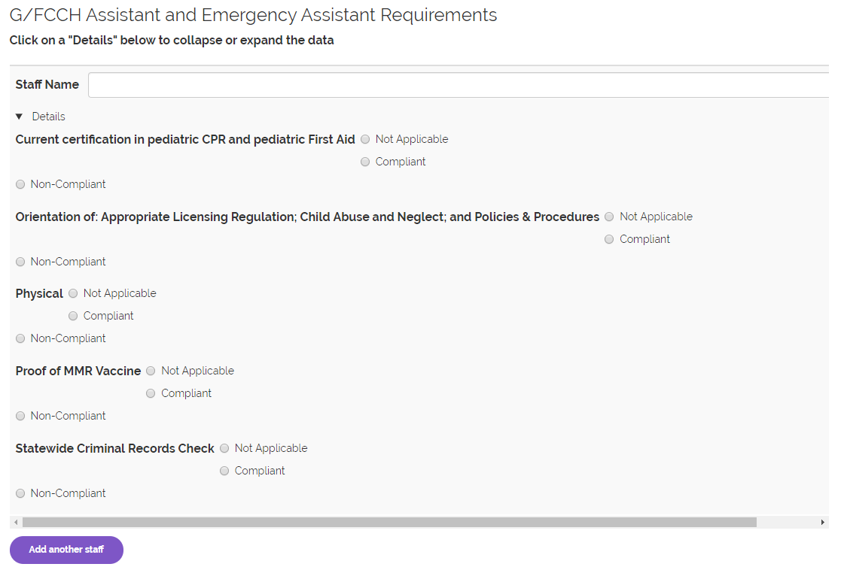

On the last page of the web form, the assessor goes through the checklists, action plans, obtains signatures from all relevant parties and submits the form. On the Additional reporting section, if the assessor selects yes, then more details will be required. When the assessor selects referral made as a result of corrective action, the provider/program receives an email notification and a reminder in two weeks of items that were non-compliant during the assessor’s visit.

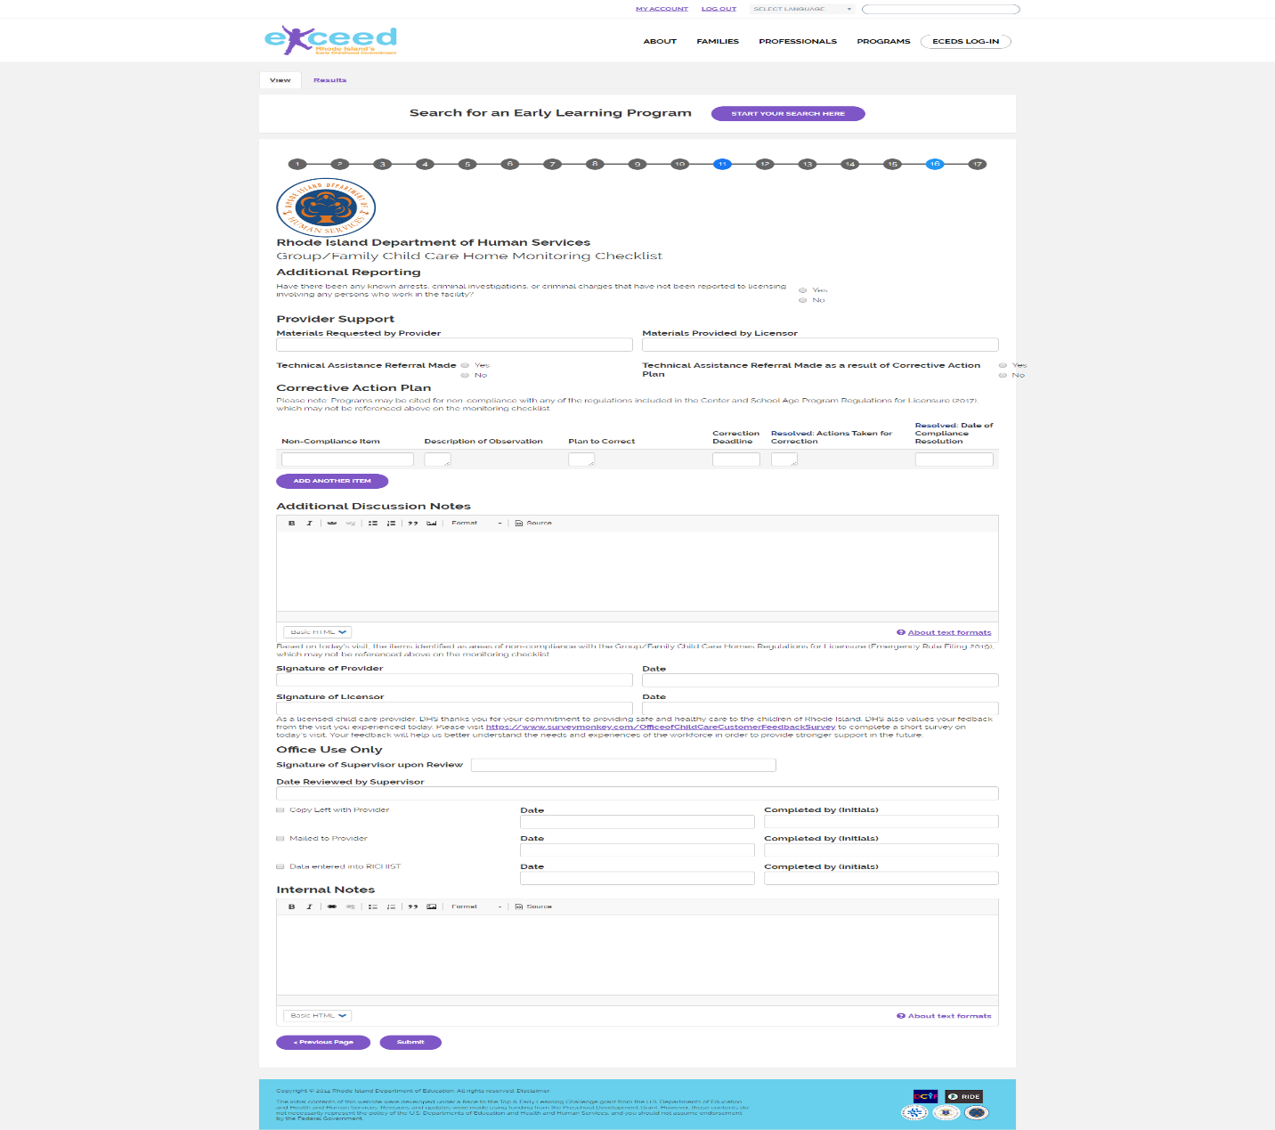

**Please Note**: Once a form has been submitted, the assessor cannot start another application process for that provider/program. The error message below is displayed if a new application is started for the program. The assessor/licensor can edit submissions at any time before it gets published to Exceed.

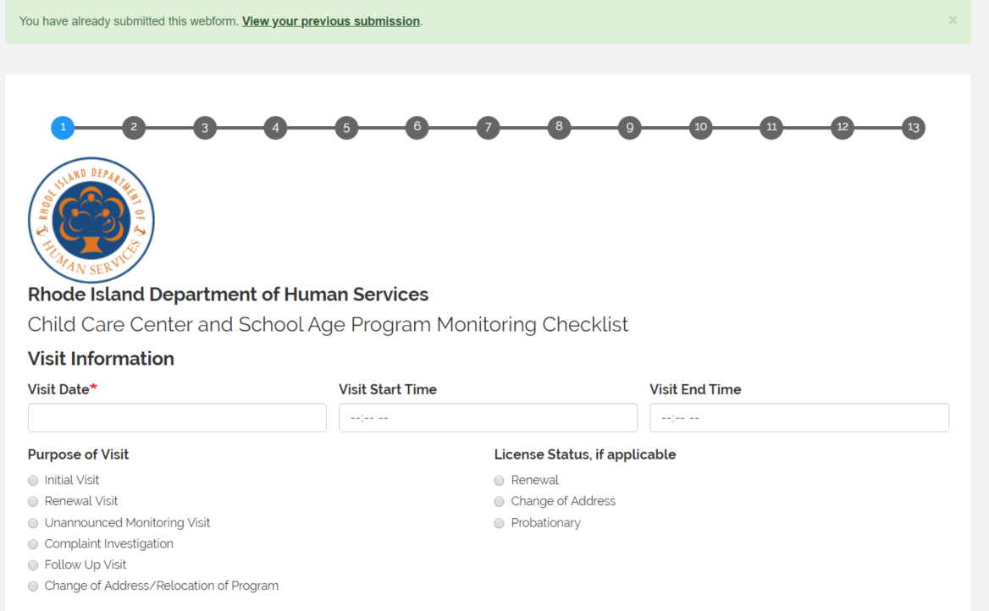

1. **The supervisor**

* Log in

The supervisor follows the same steps to log in via ECEDS as an assessor.

* Review Process

The supervisor gets an email notification when an application has been submitted by an assessor. The supervisor either follows the link in their email or logs in via ECEDS to access the licensing and monitoring module. The supervisor can filter their dashboard by status or by the program/provider information. The supervisor’s role is simple – review submissions and carry out the necessary actions which is either an approval or a rejection.

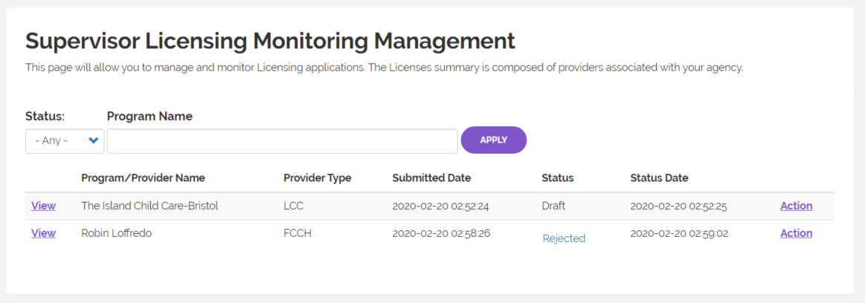

The “View” button gives the supervisor the ability to review the submitted application and the “Action” functionality allows the supervisor to select the necessary actions – Approve or Reject application.

If the application gets approved, the assessor gets a notification and this submitted web form gets published to the consumer facing portal in Exceed. If the application is rejected, the supervisor includes a note to the assessor with reasons why an application has been rejected. The assessor then upon receipt of an email, makes the necessary edits and submits again.

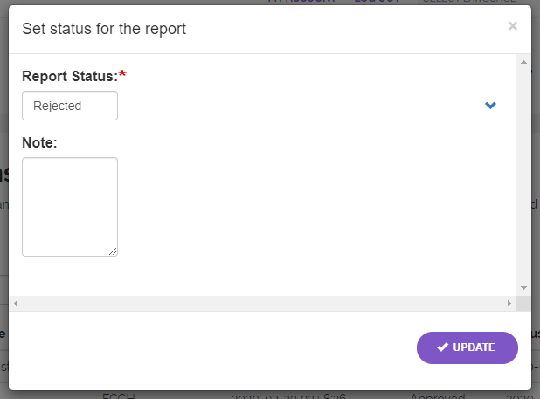

**Please Note** – An assessor can edit an application numerous times and the supervisor can approve or reject and application. If a supervisor approves an application and it gets published, this application can be withdrawn from Exceed in two ways. One, the supervisor changes the status from their landing page or a supervisor can remove the published report.

1. **The Consumer**

The consumer is not involved in any of the processes described above. If an application gets approved by the supervisor, that application is published and the consumer can access this in Exceed (on the Early Learning Program search page and the Search summary page).

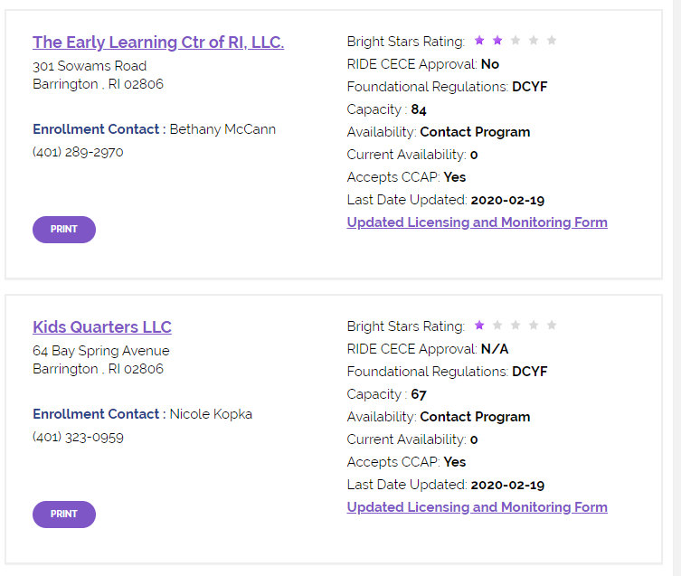

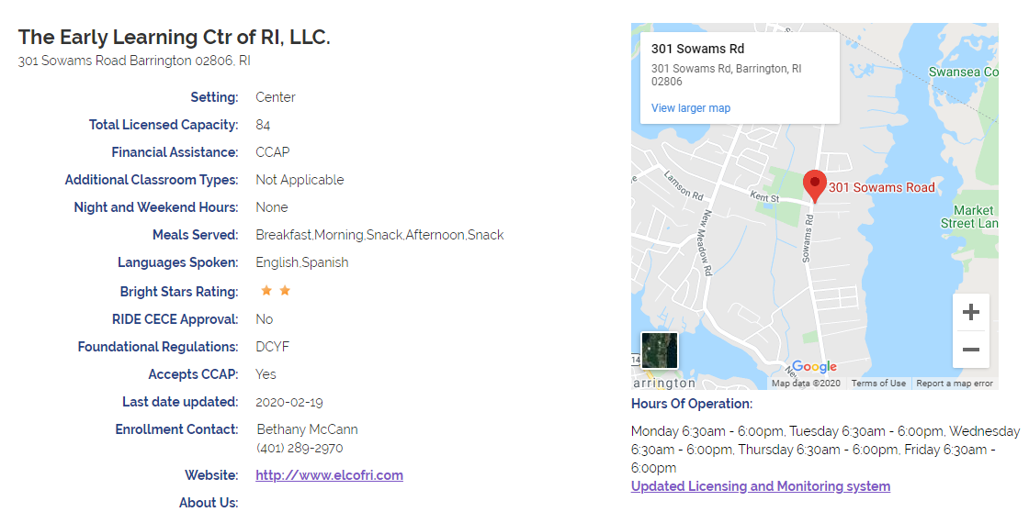

**Reports**

When this module is fully functional, we can pull reports in two ways. One from Views in Drupal or alternatively by use of a specific query language from the database. We will document these query language Examples in the appendix.

1. Monitoring-visits

This report will show information about the visits that have been recorded on these forms. It can be filtered by date (or range) or assessor/licensor name. To produce this report follow this link to display the page below - <https://exceed.ri.gov/monitoring-visits>

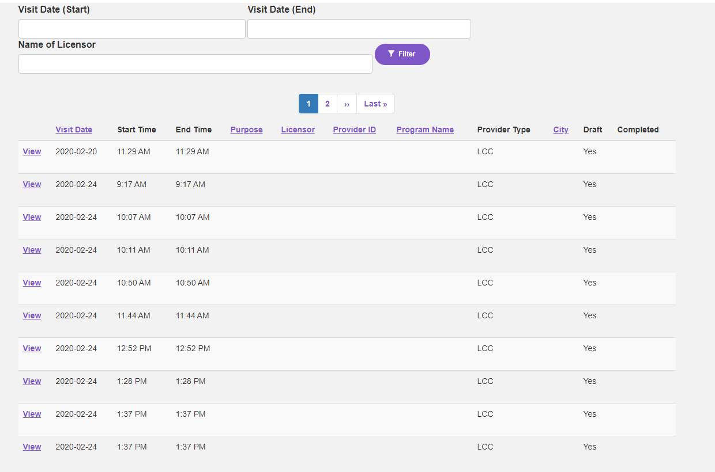

If other filter criteria is needed, we recommend using Drupal View which allows additional filter criteria and output fields to be added to it.

To add a filter criteria to a view:

* Login to Drupal by clicking the link below <https://exceed.ri.gov/user/login> and enter credentials.
* Navigate to <https://exceed.ri.gov/monitoring-visits> to see the monitoring visits report.
* To edit the view, select the ‘Edit’ button or just hover over the view.



* When ‘Edit view’ is selected, the user can display the page below.

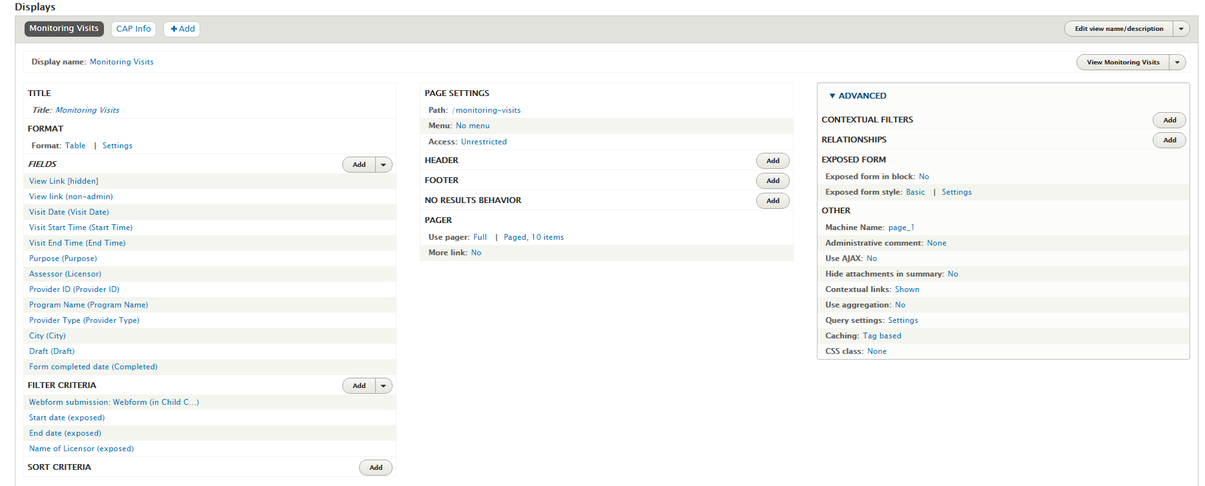

* The ‘FIELDS’ section shows all the fields that will be displayed once a report is generated. The ‘FILTER CRITERIA’ shows the filter fields and the ‘PAGER’ displays where the page count/record settings can be set.
* To add more filter fields, select the ‘Add’ button on the ‘FILTER CRITERIA’ section. This action displays the page below.

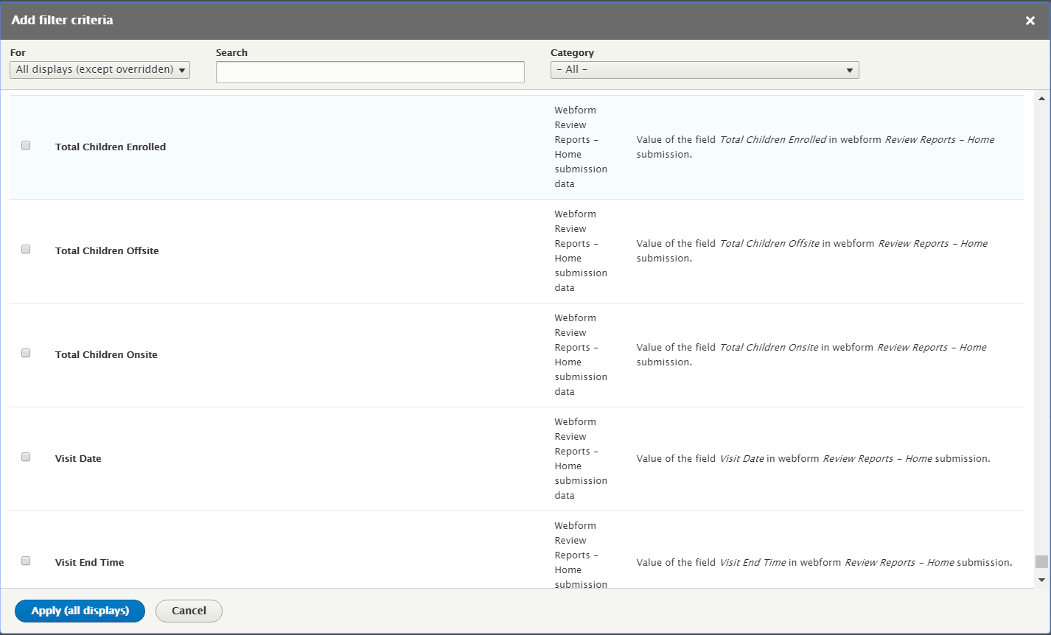

* In Search field, the user can type in the field name, select the required field and select ‘Apply (all displays)’ button.
* A second popup page is displayed where the user will configure the filter field according to the requirements.

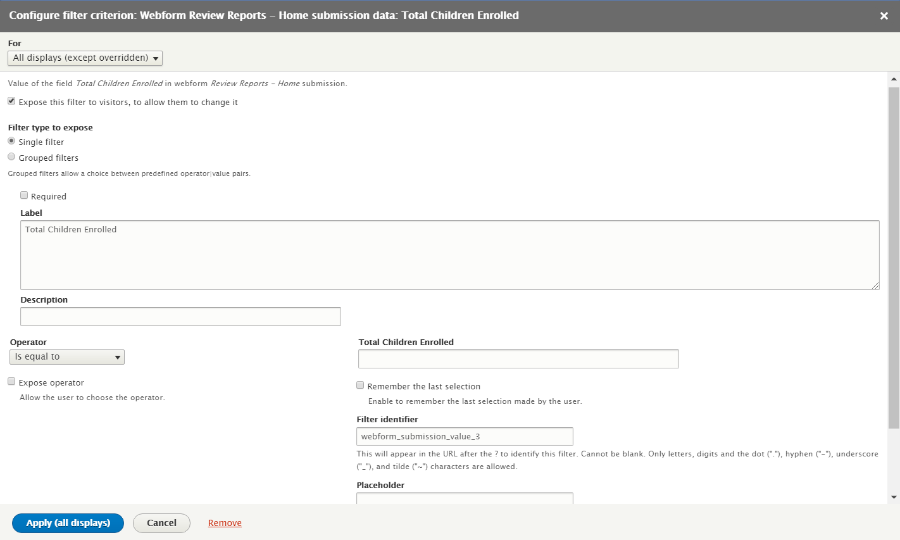

**Please Note** – enable the ‘Expose this filter to visitors’ option so that the filter criteria will be displayed correctly. The user can select ‘Single’ or ‘Grouped’ filter options. If a ‘single filter’ option is selected, this will display a text box. If a ‘Grouped filter’ option is selected, this will display a radio button or a check box with multiple options.

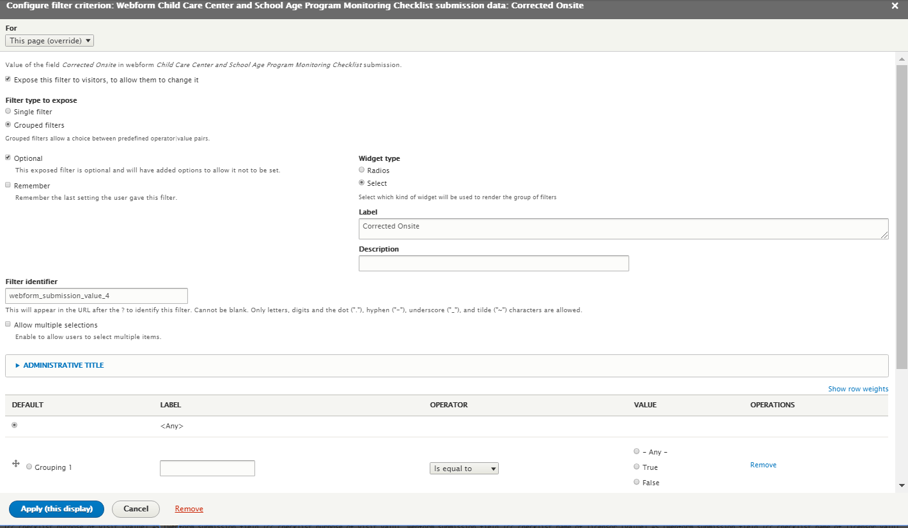

* Once the configurations are made, the user should select ‘Apply’ to complete the process. This process will add the necessary filter fields to the filter criteria.

**Please Note**: If these steps are followed and the edits are not visible on the front end, follow these steps outlined below -

Go to Configuration 🡪 Development 🡪 Performance 🡪 Clear all caches. This will clear all the existing Drupal cache and the changes can be seen on the Front end.

**Please Note –** We have provided a data dictionary with fields that can be added to the filter criteria. We strongly recommend that users should NOT attempt to edit other views like ‘Program search’ or ‘Program search details’ since any misconfiguration will break the entire view and page.

1. **CAP- info**

This report pulls information from the Corrective Action Plans in the forms that have been submitted. It can be filtered by dates, assessor, risk level and application status. To view this report navigate to tis link to display the page below <https://exceed.ri.gov/cap-info>. The same process as the described above will be followed if additional filter criteria is needed.

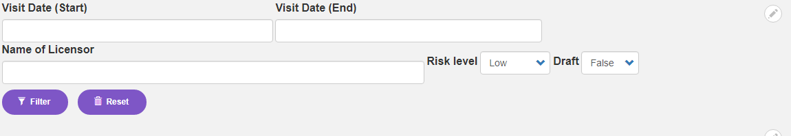

**Appendix**

An alternate solution to creating a view would be to run a query command to generate reports. I have included examples below of query commands.

**Monitoring Visits Query**

SELECT DISTINCT TOP(10) webform_submission_field_lcc_checklist_visit_date.[value] AS [webform_submission_field_lcc_checklist_visit_date_value], webform_submission_field_lcc_checklist_visit_start_time.[value] AS [webform_submission_field_lcc_checklist_visit_start_time_valu], webform_submission_field_lcc_checklist_visit_end_time.[value] AS [webform_submission_field_lcc_checklist_visit_end_time_value], webform_submission_field_lcc_checklist_purpose_of_visit.[value] AS [webform_submission_field_lcc_checklist_purpose_of_visit_valu], webform_submission_field_lcc_checklist_name_of_licensor.[value] AS [webform_submission_field_lcc_checklist_name_of_licensor_valu], webform_submission_field_lcc_checklist_provider_id.[value] AS [webform_submission_field_lcc_checklist_provider_id_value], webform_submission_field_lcc_checklist_program_name.[value] AS [webform_submission_field_lcc_checklist_program_name_value], webform_submission_field_lcc_checklist_provider_type.[value] AS [webform_submission_field_lcc_checklist_provider_type_value], webform_submission_field_lcc_checklist_city.[value] AS [webform_submission_field_lcc_checklist_city_value], exc_drupal_webform_submission.[sid] AS [sid]

FROM

exc_drupal_webform_submission

LEFT JOIN exc_drupal_webform_submission_data webform_submission_field_lcc_checklist_visit_date ON exc_drupal_webform_submission.sid = webform_submission_field_lcc_checklist_visit_date.sid AND (webform_submission_field_lcc_checklist_visit_date.name = 'visit_date' AND webform_submission_field_lcc_checklist_visit_date.delta = '0')

LEFT JOIN exc_drupal_webform_submission_data webform_submission_field_lcc_checklist_visit_start_time ON exc_drupal_webform_submission.sid = webform_submission_field_lcc_checklist_visit_start_time.sid AND (webform_submission_field_lcc_checklist_visit_start_time.name = 'visit_start_time' AND webform_submission_field_lcc_checklist_visit_start_time.delta = '0')

LEFT JOIN exc_drupal_webform_submission_data webform_submission_field_lcc_checklist_visit_end_time ON exc_drupal_webform_submission.sid = webform_submission_field_lcc_checklist_visit_end_time.sid AND (webform_submission_field_lcc_checklist_visit_end_time.name = 'visit_end_time' AND webform_submission_field_lcc_checklist_visit_end_time.delta = '0')

LEFT JOIN exc_drupal_webform_submission_data webform_submission_field_lcc_checklist_purpose_of_visit ON exc_drupal_webform_submission.sid = webform_submission_field_lcc_checklist_purpose_of_visit.sid AND (webform_submission_field_lcc_checklist_purpose_of_visit.name = 'purpose_of_visit' AND webform_submission_field_lcc_checklist_purpose_of_visit.delta = '0')

LEFT JOIN exc_drupal_webform_submission_data webform_submission_field_lcc_checklist_name_of_licensor ON exc_drupal_webform_submission.sid = webform_submission_field_lcc_checklist_name_of_licensor.sid AND (webform_submission_field_lcc_checklist_name_of_licensor.name = 'name_of_licensor' AND webform_submission_field_lcc_checklist_name_of_licensor.delta = '0')

LEFT JOIN exc_drupal_webform_submission_data webform_submission_field_lcc_checklist_provider_id ON exc_drupal_webform_submission.sid = webform_submission_field_lcc_checklist_provider_id.sid AND (webform_submission_field_lcc_checklist_provider_id.name = 'provider_id' AND webform_submission_field_lcc_checklist_provider_id.delta = '0')

LEFT JOIN exc_drupal_webform_submission_data webform_submission_field_lcc_checklist_program_name ON exc_drupal_webform_submission.sid = webform_submission_field_lcc_checklist_program_name.sid AND (webform_submission_field_lcc_checklist_program_name.name = 'program_name' AND webform_submission_field_lcc_checklist_program_name.delta = '0')

LEFT JOIN exc_drupal_webform_submission_data webform_submission_field_lcc_checklist_provider_type ON exc_drupal_webform_submission.sid = webform_submission_field_lcc_checklist_provider_type.sid AND (webform_submission_field_lcc_checklist_provider_type.name = 'provider_type' AND webform_submission_field_lcc_checklist_provider_type.delta = '0')

LEFT JOIN exc_drupal_webform_submission_data webform_submission_field_lcc_checklist_city ON exc_drupal_webform_submission.sid = webform_submission_field_lcc_checklist_city.sid AND (webform_submission_field_lcc_checklist_city.name = 'city' AND webform_submission_field_lcc_checklist_city.delta = '0')

WHERE ( [exc_drupal_webform_submission].[webform_id] IN ('lcc_checklist', 'fcch_checklist') )

**CAP Information Query**

SQL query for CAP info report:

SELECT DISTINCT TOP(10) webform_submission_field_lcc_checklist_visit_start_time.[value] AS [webform_submission_field_lcc_checklist_visit_start_time_valu], webform_submission_field_lcc_checklist_visit_date.[value] AS [webform_submission_field_lcc_checklist_visit_date_value], webform_submission_field_lcc_checklist_purpose_of_visit.[value] AS [webform_submission_field_lcc_checklist_purpose_of_visit_valu], webform_submission_field_lcc_checklist_name_of_licensor.[value] AS [webform_submission_field_lcc_checklist_name_of_licensor_valu], webform_submission_field_lcc_checklist_city.[value] AS [webform_submission_field_lcc_checklist_city_value], webform_submission_field_lcc_checklist_provider_id.[value] AS [webform_submission_field_lcc_checklist_provider_id_value], webform_submission_field_lcc_checklist_program_name.[value] AS [webform_submission_field_lcc_checklist_program_name_value], webform_submission_field_lcc_checklist_provider_type.[value] AS [webform_submission_field_lcc_checklist_provider_type_value], webform_submission_field_lcc_checklist_corrective_action_plan.[value] AS [webform_submission_field_lcc_checklist_corrective_action_pla], exc_drupal_webform_submission.[sid] AS [sid]

FROM

exc_drupal_webform_submission

LEFT JOIN exc_drupal_webform_submission_data webform_submission_field_lcc_checklist_visit_start_time ON exc_drupal_webform_submission.sid = webform_submission_field_lcc_checklist_visit_start_time.sid AND (webform_submission_field_lcc_checklist_visit_start_time.name = 'visit_start_time' AND webform_submission_field_lcc_checklist_visit_start_time.delta = '0')

LEFT JOIN exc_drupal_webform_submission_data webform_submission_field_lcc_checklist_visit_date ON exc_drupal_webform_submission.sid = webform_submission_field_lcc_checklist_visit_date.sid AND (webform_submission_field_lcc_checklist_visit_date.name = 'visit_date' AND webform_submission_field_lcc_checklist_visit_date.delta = '0')

LEFT JOIN exc_drupal_webform_submission_data webform_submission_field_lcc_checklist_purpose_of_visit ON exc_drupal_webform_submission.sid = webform_submission_field_lcc_checklist_purpose_of_visit.sid AND (webform_submission_field_lcc_checklist_purpose_of_visit.name = 'purpose_of_visit' AND webform_submission_field_lcc_checklist_purpose_of_visit.delta = '0')

LEFT JOIN exc_drupal_webform_submission_data webform_submission_field_lcc_checklist_name_of_licensor ON exc_drupal_webform_submission.sid = webform_submission_field_lcc_checklist_name_of_licensor.sid AND (webform_submission_field_lcc_checklist_name_of_licensor.name = 'name_of_licensor' AND webform_submission_field_lcc_checklist_name_of_licensor.delta = '0')

LEFT JOIN exc_drupal_webform_submission_data webform_submission_field_lcc_checklist_city ON exc_drupal_webform_submission.sid = webform_submission_field_lcc_checklist_city.sid AND (webform_submission_field_lcc_checklist_city.name = 'city' AND webform_submission_field_lcc_checklist_city.delta = '0')

LEFT JOIN exc_drupal_webform_submission_data webform_submission_field_lcc_checklist_provider_id ON exc_drupal_webform_submission.sid = webform_submission_field_lcc_checklist_provider_id.sid AND (webform_submission_field_lcc_checklist_provider_id.name = 'provider_id' AND webform_submission_field_lcc_checklist_provider_id.delta = '0')

LEFT JOIN exc_drupal_webform_submission_data webform_submission_field_lcc_checklist_program_name ON exc_drupal_webform_submission.sid = webform_submission_field_lcc_checklist_program_name.sid AND (webform_submission_field_lcc_checklist_program_name.name = 'program_name' AND webform_submission_field_lcc_checklist_program_name.delta = '0')

LEFT JOIN exc_drupal_webform_submission_data webform_submission_field_lcc_checklist_provider_type ON exc_drupal_webform_submission.sid = webform_submission_field_lcc_checklist_provider_type.sid AND (webform_submission_field_lcc_checklist_provider_type.name = 'provider_type' AND webform_submission_field_lcc_checklist_provider_type.delta = '0')

LEFT JOIN exc_drupal_webform_submission_data webform_submission_field_lcc_checklist_corrective_action_plan ON exc_drupal_webform_submission.sid = webform_submission_field_lcc_checklist_corrective_action_plan.sid AND (webform_submission_field_lcc_checklist_corrective_action_plan.name = 'corrective_action_plan' AND webform_submission_field_lcc_checklist_corrective_action_plan.delta = '0')

WHERE ( ([exc_drupal_webform_submission].[webform_id] IN ('lcc_checklist', 'fcch_checklist')) AND ([exc_drupal_webform_submission].[in_draft] = '0') )

**Please Note -** to use this query,

* The client needs to VPN into the RIDE Production database server and connect to exceed_drupal database in order to execute this query.
* This is a Drupal query and will need to be altered to work in a SQL environment. For example, add “exc_drupal” before table names.
* Internal field names cannot be identified in the database so additional filter criteria cannot be added to this command.